**Part 1**

* **Java Operators** (Precedence high to low)

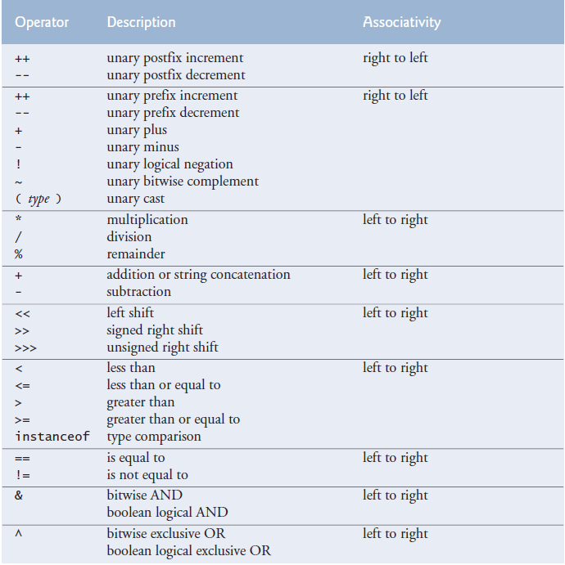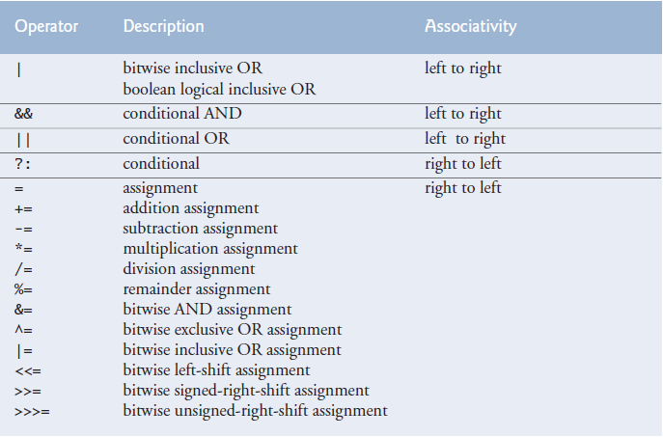

- x = 16 - - 5 -> 16 - (-5) -> x = 16 + 5

x = 16 --5; // Error

x = x++; // Does nothing

-The equality operator “==” should be read as “is equal to” and the assignment operator as “gets the value of” or “gets” to avoid confusion.

- a = b + c; // First b + c is calculated and stored in a temporary place then it is assigned to a.

-We can use x % y and x / y to get rid of/gather certain digits. More information on “Programming Tricks” file.

-In java you cant manipulate data using different format specifiers, using “ quote mark or

‘ apostrophe. In C, print %c, ‘A’ prints the character A. print %d, ‘A’ prints 65. print %c, 65 prints A. You cant be unsafe like this in java. You cant use random format identifiers. You have to use methods that parse or operators that cast types.

**-**Use parantheses to override operator precedence.

**-Operators based on operand number:**

**-Unary operator:** Contains one operand like ‘++a;’. Operand means “processed”.

**-Binary operator:** Contains two operands like “a = b;”.

**-Ternary operator:** Contains three operators like “a > b ? a = 0 : a = 1;”. The only ternary operator in Java is conditional operator.

-Unlike binary operators, the unary increment and decrement operators should be placed

next to their operands, with no intervening spaces.

passes = passes + 1; // Three different ways of incrementing.

passes += 1;

++passes;

passes++;

**-Bitwise operators**

public static void main(String args[]) {

int a = 60; /* 60 = 0011 1100 */

int b = 13; /* 13 = 0000 1101 */

int c = 0;

c = a & b; /* 12 = 0000 1100 */

System.out.println("a & b = " + c );

c = a | b; /* 61 = 0011 1101 */

System.out.println("a | b = " + c );

c = a ^ b; /* 49 = 0011 0001 */

System.out.println("a ^ b = " + c );

c = ~a; /*-61 = 1100 0011 */

System.out.println("~a = " + c );

c = a << 2; /* 240 = 1111 0000 */

System.out.println("a << 2 = " + c );

c = a >> 2; /* 15 = 1111 */

System.out.println("a >> 2 = " + c );

c = a >>> 2; /* 15 = 0000 1111 */

System.out.println("a >>> 2 = " + c );

}

**-Shorthand operators:** A shorthand operator is a shorter way to express something that is already available in the Java programming language. Examples are compund operators and increment operators.

**-Compound operators:** += -= *= /= %= operators are compound operators. They are short versions of operators like

x = x + 2;

x =+ 2;

-Compound operators have built in cast operators.

int i = 5;

long j = 8;

i = i + j; // Will not compile

i += j; // Will compile

because

i += j;

stands for

i = (int)(i + j);

* x =+ 5 -> x = (+5)

x += 5 -> x = x + 5

**-Increment and decrement operators:** Used to add or substract 1 from the value of a numeric variable.

-Attempting to use the increment or decrement operator on an expression other than one to which a value can be assigned is a syntax error. For example, writing ++(x + 1) is a syntax

error, because (x + 1) is not a variable, it is an expression.

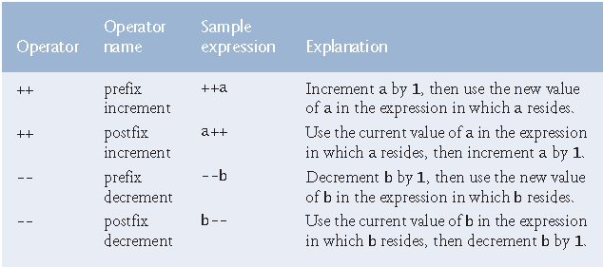

-Using the prefix increment (or decrement) operator to add 1 to (or subtract 1 from)

a variable is known as preincrementing(or predecrementing). This causes the variable to

be incremented (decremented) by 1; then the new value of the variable is used in the

expression in which it appears. Using the postfix increment (or decrement) operator to add

1 to (or subtract 1 from) a variable is known as postincrementing(or postdecrementing).

This causes the current value of the variable to be used in the expression in which it

appears; then the variable’s value is incremented (decremented) by 1.

z = x++ + y;

-When incrementing or decrementing a variable in a statement by itself, the prefix

increment and postfix increment forms have the *same* effect, and the prefix decrement and

postfix decrement forms have the *same* effect. It’s only when a variable appears in the context

of a larger expression that preincrementing and postincrementing the variable have

different effects (and similarly for predecrementing and postdecrementing).

* **Java Data Types:**

The table lists the eight primitive types in Java. Like its predecessor languages C and C++, Java requires all variables to have a type. For this reason, Java is referred to as a strongly typed language.

In C and C++, programmers frequently have to write separate versions of programs to support different computer platforms, because the primitive types are not guaranteed to be identical from computer to computer. For example, an int on one machine might be represented by 16 bits (2 bytes) of memory, on a second machine by 32 bits (4 bytes), and on another machine by 64 bits (8 bytes). In Java, int values are always 32 bits (4 bytes).6

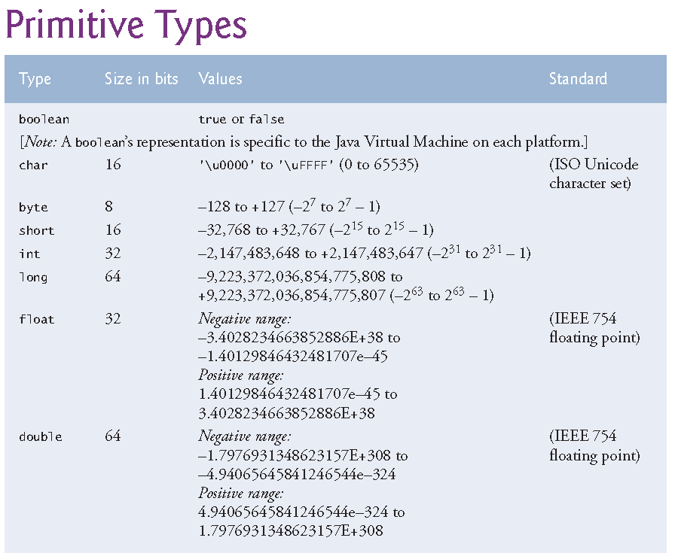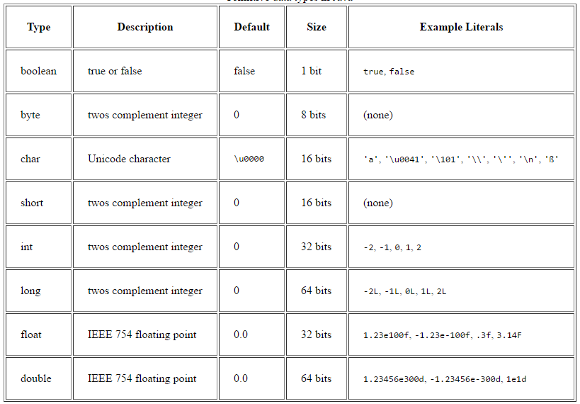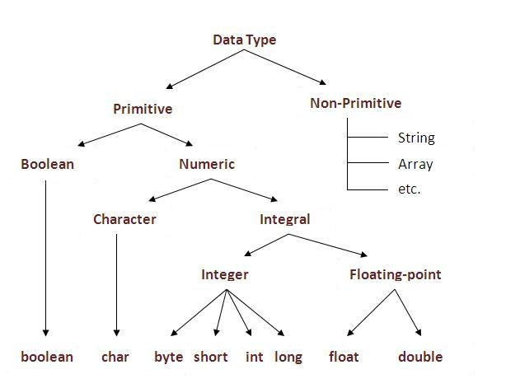

**-Default data types:** As you can see in chart above when we are using char values we must use it between ‘ ’. When using string we must do it between “ ”. When using long we must use L after it. When using float we put F after it. When using floating point values dont ignore the decimal point.

In java every single integer number is considered type int and every single floating point value is considered type double.

float myVariable = 9;

Code above means you are creating a floating point copy (9.0) of the 9 integer literal and then assigning that to float type myVariable.

float myVariable = 9.5;

In the code above you are trying to assign a double type literal to a float type variable, which requires an explicit type casting. The statement won't compile. You need to add a cast there.

float myVariable = (float) 9.5;

If you dont want casting/conversion then you need to use suffixes.

float myVariable = 9.5F;

In the code above you are assigning 9.5 is float type literal to a float type variable.

-Suffixes are only needed for literal values. You dont need to use them when you are inputting data to program. This is not a problem in java because when you are reading a value from user you are doing it with methods like nextDouble, nextFloat. So you dont have to worry about losing data by assigning a float to double. But you have to write a robust program that checks for and handles errors and wrong values.

-When you are reading values with methods like nextFloat() you the program doesnt reject the 5.0 double value because it uses a casting operator behind the scenes.

**-Default values:** Default values of primivite type variables and reference type variables(objects)

|  |  |
| --- | --- |
| **Data Type** | **Default Value (for fields)** |
| Byte | 0 |
| short | 0 |
| int | 0 |
| long | 0L |
| float | 0.0F |
| double | 0.0 |
| Char | '\u0000' |
| Boolean | false |
| String, Object | Null |

-Default values are not assigned to local variables. They are assigned only to instance variables.

**-Size of bool:** Size of primitive bool variable changes. It can be 8 or 16 or more bits. If you want bool variables that are one bit big than you need to use bool arrays.

<https://docs.oracle.com/javase/7/docs/api/java/util/BitSet.html>

-It is easy to comprehend overflow in integers. When you are calculating floating point values for example e, Capture the number gets so small that it overflows and becomes negative. Thats why when you are calculating e, after a while it starts to subtract instead of adding.

-A variable exceeding its max or min limit is known as arithmetic overflow and causes undefined behaviour.

-Maximum and minimum value that can be stored in an int variable are represented by constants MIN_VALUE and MAX_VALUE, which are defined in class Integer. There are similar constants for the other integral types and for floating point types. Each primitive type has a corresponding class type in package java.lang.

-Char can represent letters, digits, special characters(*, %), escape sequences(\n). Chars are held as integers in the computer.

-Char is unsigned.

-Java uses UTF-16.

-Most Java program text consists of [ASCII](https://en.wikipedia.org/wiki/ASCII) characters, but any Unicode character can be used as part of identifier names, in comments, and in character and string literals. For example, π (which is the Greek Lowercase Letter pi) is a valid Java identifier. ASCII character set is a subset of the Unicode® character set used by Java. Java uses unicode characters and IEEE 754 floating –point numbers.

char unicode1 = 'a'; // Assigning an ascii character to a char variable.

char unicode1 = 'ş'; // Assigning an non-ascii character to a char variable.

char unicode2 = '\u2202'; // Assigning a unicode character to a char value.

-Constant integral expression—that is, any combination of integer constants that evaluates to a constant integer value (e.g., –7, 0 or 221)—. An integer constant is simply an integer value (integer literal). In addition, character constants (character or string literals)—specific characters in single quotes, such as 'A', '7' or '$'—which represent the integer values of characters and enum constants.

Constant variable—a variable containing a value which does not change for the entire program. Such a variable is declared with keyword final. Enum type constants can also be used in case labels. We cant assıgn values of variables to constant variables. That would make our constant variable able to change.

-Java has strings but they are not variables, they are classes. You do the initialization and then you manipulate the data using methods of the class.

**-Binary, integers and floating point values:**

<http://www.free-test-online.com/binary/signed_converter.html> We notes about this subject on left side of c programming language book too.

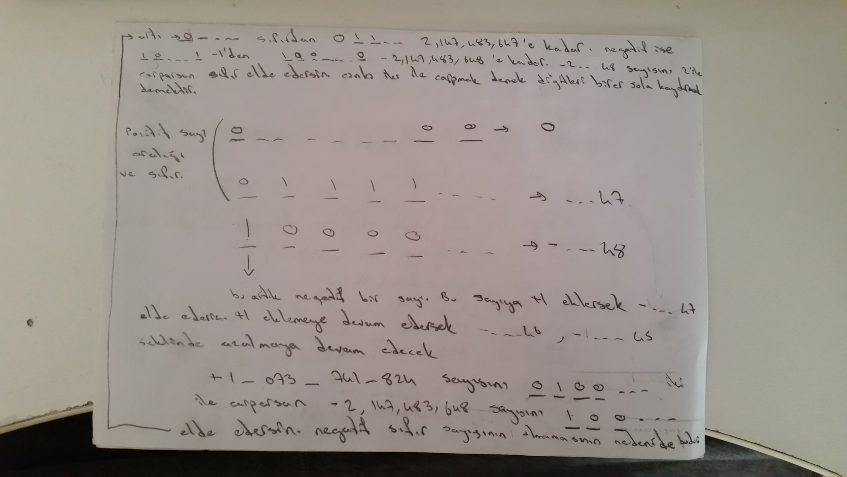

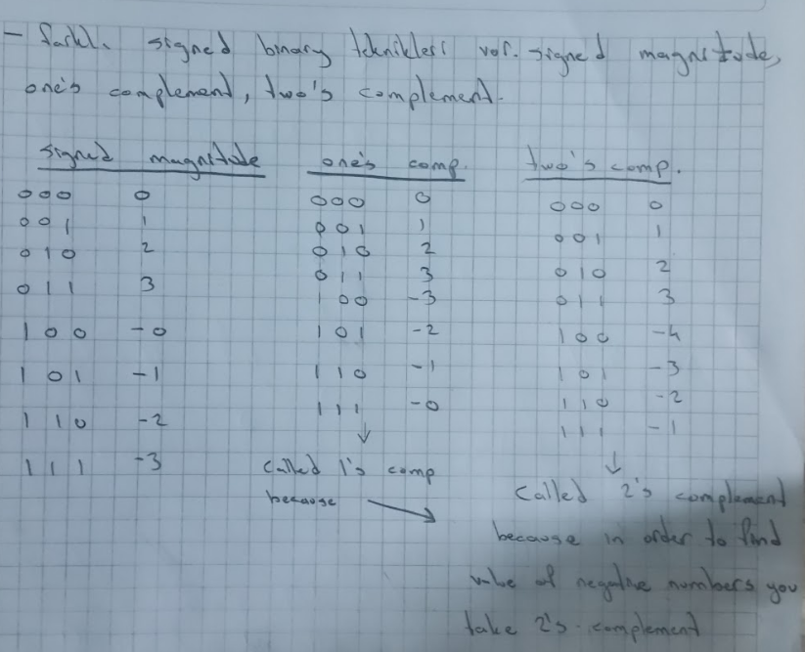

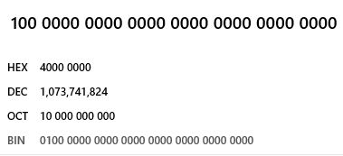

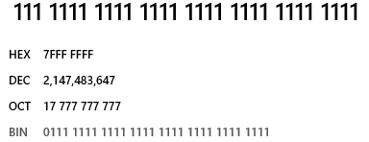

-Left most bit is not data. It is sign bit. 0 for positive 1 for negative. When we have 1000...0 we get -2....48. Negative numbers are two’s complement in Java so when you take two’s complement of a negetive number(binary) you can see its value. For example 1111 is -1. We think of 111 as 000. Which means its 0 but we add 1.

When you see an octal or hexadecimal value, the way to converting how many bits is that is: How many bits does it take to write one value in that base.(8 in octal 16 in hex.) So it would take 3 bits to code 8 different combinations and it would take 4 bits to code 16 different combinations. So if you see the number 7FFF EFB0, that means it would take 8 x 4 = 32 bits to encode that hexadecimal value. Also this is the reasoning behind the conversion we do in logic circuit design.

-Integer and floating point numbers are held in computer as shown below:

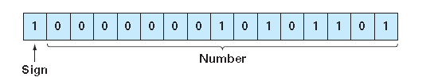

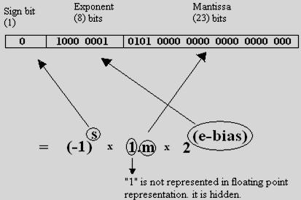

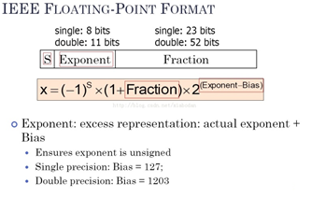

-Float variables areSingle precision(32 bits) floating point numbers. Can hold up to 7 significant digits. Double variables are double precision(64 bits) floating point numbers. Double require twice the memory but can hold 15 significant digits.

-Floating point numbers are not %100 precise. We have float, double and BigDecimal depending on our needs.

**-BigDecimal**(import java.math.BigDecimal;):

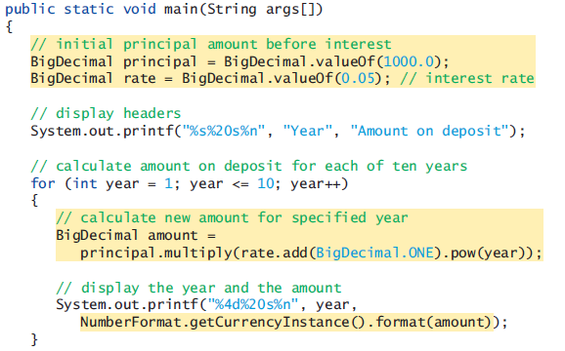

- First, the expression rate.add(BigDecimal.ONE) adds 1 to the rate to produce a BigDecimal containing 1.05—this is equivalent to 1.0 + rate in line 19 of Fig. 5.6. The BigDecimal constant ONE represents the value 1. Class BigDecimal also provides the commonly used constants ZERO (0) and TEN (10).

Next, BigDecimal method pow is called on the preceding result to raise 1.05 to the power year—this is equivalent to passing 1.0 + rate and year to method Math.pow in line 19 of Fig. 5.6.

Finally, we call BigDecimal method multiply on the principal object, passing the preceding result as the argument. This returns a BigDecimal representing the amount on deposit at the end of the specified year.

**-NumberFormat**(import java.text.NumberFormat;): European locale: 1.234,56, US locale: 1,234.56.

During each iteration of the loop, line 26 evaluates

NumberFormat.getCurrencyInstance().format(amount)

as follows:

1. First, the expression uses NumberFormat’s static method getCurrencyInstance to get a NumberFormat that’s pre-configured to format numeric values as localespecific currency Strings—for example, in the U.S. locale, the numeric value 1628.89 is formatted as $1,628.89. Locale-specific formatting is an important part of internationalization—the process of customizing your applications for users’ various locales and spoken languages.

2. Next, the expression invokes method NumberFormat method format (on the object returned by getCurrencyInstance) to perform the formatting of the amount value. Method format then returns the locale-specific String representation, rounded to two-digits to the right of the decimal point.

**-Rounding BigDecimal values**(import java.math.MathContext;)**:** BigDecimal also gives you control over how values are rounded—by default all calculations are exact and no rounding occurs. If you do not specify how to round BigDecimal values and a given value cannot be represented exactly—such as the result of 1 divided by 3, which is 0.3333333…—an ArithmeticException occurs. You can specify the rounding mode for Big-Decimal by supplying a MathContext object (package java.math) to class BigDecimal’s constructor when you create a BigDecimal. You may also provide a MathContext to various BigDecimal methods that perform calculations. By default, each pre-configured MathContext uses so called “bankers rounding”

**-Scaling BigDecimal values:** A BigDecimal’s scale is the number of digits to the right of its decimal point. If you need a BigDecimal rounded to a specific digit, you can call BigDecimal method setScale. For example, the following expression returns a BigDecimal with two digits to the right of the decimal point and using bankers rounding:

amount.setScale(2, RoundingMode.HALF_EVEN)

**-Data type changes:**

**-Explicit type change:**

**-Cast operator:** A cast operator can be used to convert between primitive numeric types, such as int and double, and between related reference types (as we discuss in Chapter 10, Object-Oriented Programming: Polymorphism and Interfaces). Casting to the wrong type may cause compilation errors or runtime errors.

You cant make an assigment that would cause data lose in java. Also you are not allowed you use two different data type in a calculation. In order to do these you need to use cast operator.

-Dividing two integers result in integer division, any fractional part of the calculation is truncated(removed). Integer division doesnt round. It truncates. So 7/4 wont result in 1,5 rounding to 2. It will result in 1.5 truncating to 1.

To perform a floating point calculation with integer values, we must *temporarily* treat these values as floating point numbers for use in the calculation. Java provides the unary cast operator to accomplish this task. For example (double) cast operator—a unary operator— can be used to create a *temporary* floating-point copy of its operand total (which appears to the right of the operator). Using a cast operator in this manner is called explicit conversion or type casting. The value stored in total is still an integer.

average = (double) total / counter

**-Implicit type change:**

The calculation now consists of a floating-point value (the temporary double copy of

total) divided by the integer gradeCounter. Java can evaluate only arithmetic expressions

in which the operand’s types are *identical*. To ensure this, Java performs an operation

called promotion (or implicit conversion) on selected operands. For example, in an

expression containing int and double values, the int values are promoted to double

values for use in the expression. Then floating-point division is performed and the result of the calculation is assigned to average. As long as the (double) cast operator is applied to *any* variable in the calculation, the calculation will yield a double result.

Argument promotion is done in expressions and method argument-parameter type matching.

-float i = 13;

-int c = 12;

someMethod(c);

void someMethod(double c1){

…

}

-The result of an expression involving anything int sized or smaller is always int. This is because

byte b1 = 12;

byte b2 = 13;

byte b3 = b1 + b2; // Compiler error. Possible lossy conversion from int to byte.

byte b4 = 21 + 12; // Compiles, implicit cast.

**­-Other type changing ways:** So we learned explicit and implicit way to change data types among primitive types and reference types. But how to we make both primitives and reference to strings or how do we make a string primitive or reference? Here is how.

Are toString and parse just for primitive <-> string or can we use them for references too.

Long maxNumber = 1_000_000;

Long minNumber = 1;

String stringNumber = Long.toString(maxNumber);

String stringNumber2 = String.valueOf(x1); // Use valueOf instead of toString because it returns null instead of throwing an exception when reference doesnt point to anything.

int numberString = Integer. parseInt(stringNumber);

**-Integer Unicode code to char and string:**

int code = 2202;

String unicodeString = Character.toString((char)code);

**-Format specifiers**

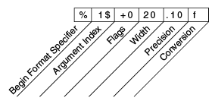

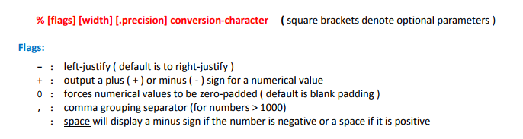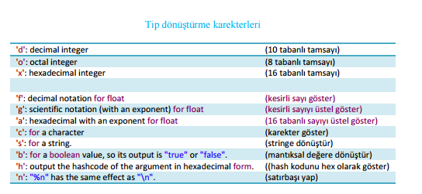

-These in table above are not format specifiers, they are just conversion character part of whole format specifier.

You can convert a numbers base using the code below. You can convert a number to any base you want. There are two toString methods in primitive data type classes. It can take only a value or a value and a radix.

Integer.toString(x, 2); // Binary

Integer.toString(x, 8); // Octal

Integer.toString(x, 16); // Hexadecimal

The table below just shows how you can write numbers in other bases instead of 10. They dont convert integer values to another type of values.

// Decimal declaration and possible chars are [0-9]

int decimal = 495;

// HexaDecimal declaration starts with 0X or 0x and possible chars are [0-9A-Fa-f]

int hexa = 0X1EF;

// Octal declaration starts with 0 and possible chars are [0-7]

int octal = 0757;

// Binary representation starts with 0B or 0b and possible chars are [0-1]

int binary = 0b111101111;

**-ASCII, Unicode character sets:**

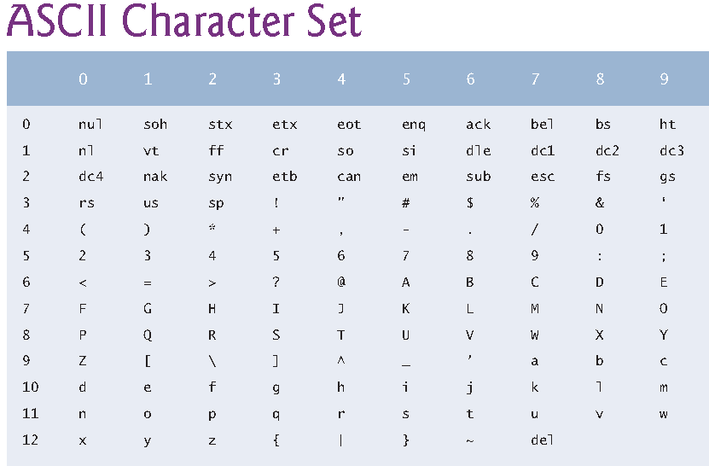

-For a unicode character we use \u0000 to \uffff

**-Control characters, escape characters, escape sequences:** “\” is an escape character which triggers an escape sequence. \n is an escape sequence. When a backslash appears in a string, Java compines it with the next character to form an escape sequence.

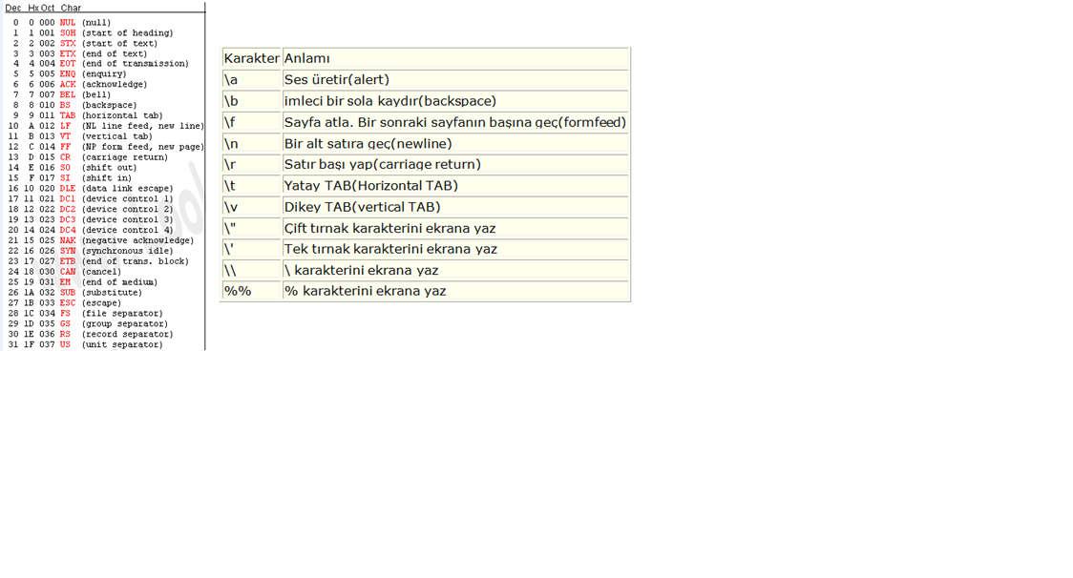

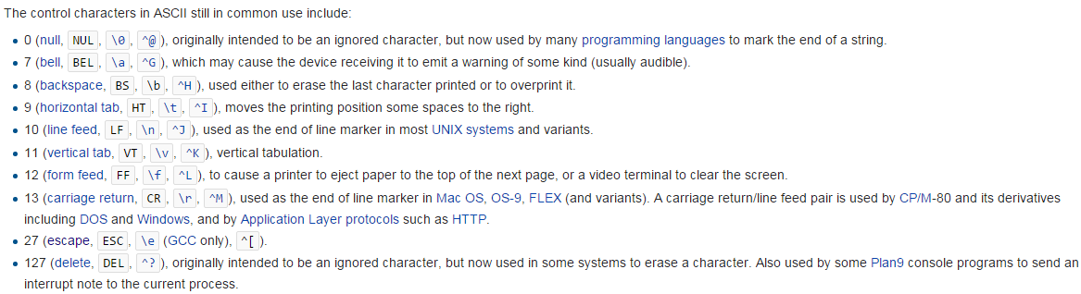

**-**\r returns the cursor to the beginning of the current line. Further character outputs for that line insert until there are no more old characters to insert over and then you keep adding normally.

-In Java string literals cant have escape sequences in them. So we can just assign them to strings. So in Java only format strings can have escape sequences in them unlike C#.

-\t is not static number of spaces. It pushes until the next tab is reached.

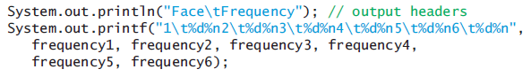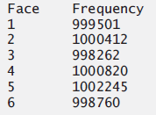

* **Java keywords and Reserved Words:** Reserved for use by java and are always spelled all lowercase letters.

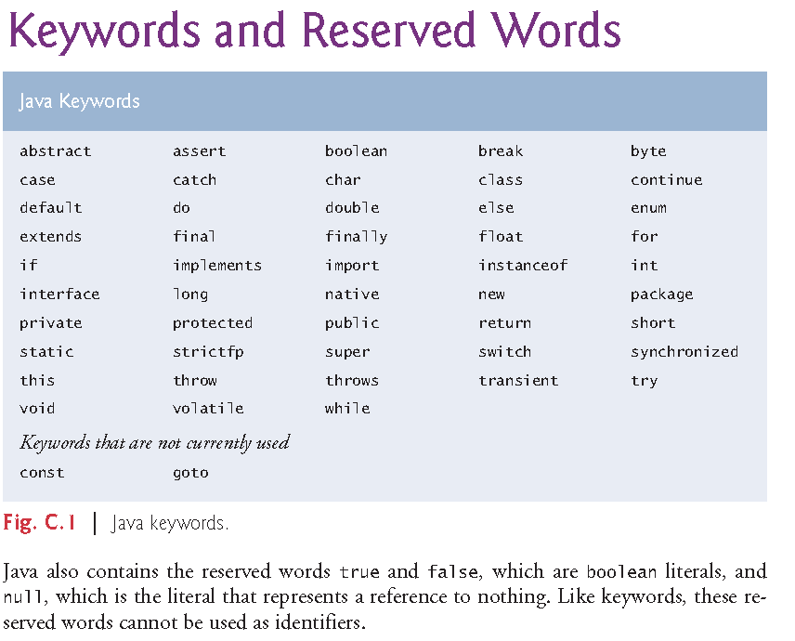

**-Literals:** In java, keywords are words that will always do a certain action and cant be used as identifiers. Literals however are words that will always stand for a certain value and cant be used as identifiers. An example to a keyword is “for” and literals in java are “true”, “false” and “null”.

Other things in source code that stand for a fixed amount are literals too. For example a “3.75” in the source code is a floating point literal. It takes space like a variable. “3” is an integer literal.

**-Native:** The native keyword is applied to a method to indicate that the method is implemented in native code using JNI (Java Native Interface).

**-More information about keywords:** For more information on each keyword use Ctrl+F.

**Part 2**

* **History and Physiology of Java**

-See “Java history, JDK” file for this information.

* **Programming Style / Conventions**

-Everything in Java(including mathematical expressions) is written in straight line form. Which means there is no superscript and subscript.

-Java is case sensitive(java commands are case sensitive too)**.**

**-Identifier:** The names we give to Classes, methods and variable names to access them easily instead of using adress. Identifiers consist of letters, digits, underscores(_) and dollar signs($) and they dont begin with a digit and dont contain spaces. You also cant use keywords.

But the convention is;

-Starting with a letter,(identifiers doesnt start with a digit so compiler understands its not a number.

-Dollar sign is not used at all,

-Use names for identifiers instead of abbreviations.

- If you are naming more than one words(methods, variables etc), capitalize the first letter of the words after the first one. This is called camel case/pascal case.

-If a variable is storing a constant value, then we name it in all upper case letters: “NUM” or “NUM_GEARS” like we did with define in C. This is the only recommended way of using underscore.

-Keywords are always written in all lowercase letters.

-Class identifiers(including String), enum type identifiers start with capital letter. We dont use capital for other identifiers. We use lower case letters for method names and variables(local, instance, class instances(objects), enum instances)

-packages are written in all lowercase.

public Class Account

Account account1 = new Account();

private enum Status { CONTINUE, WON, LOST };

Status gameStatus;

-When declaring methods in Java, if there is no return type write void but if there are no parameters then just leave it empty like ().

-Use comments and prompts to explain the program both to user and the person reading the source code.

-List instance variables first in class’s body. Also declare one variable per line and explain what it is with a good identifier and comment.

-Setter and getter methods dont have to start with words set and get but it is a convention. The naming convention for a get method that returns a boolean value is to begin the name with "is" rather than "get" (such a method is commonly called a predicate method).

-Instead of using duplicate code, you should use methods. It will be easier to update, control. It will be safer, easier to implement etc.

-You can name the main method argument anything you want, but most programmers choose "args" or "argv".

-Even if you have one statement after your control statement use brackets to prevent mistakes.

-When using if else structures dont indent else if or else.

if (studentGrade >= 90)

System.out.println("A");

else if (studentGrade >= 80)

System.out.println("B");

else if (studentGrade >= 70)

System.out.println("C");

else if (studentGrade >= 60)

System.out.println("D");

else

System.out.println("F");

-Put spaces around binary operators to make it readable.

-We put a space between control statements and their conditions but we dont put a space between method names and their argument list.

if (x > 10)

factorial(x);

-Dont return a result of a calculation. Calculate it, assign it to a variable, and then return that result. Easier to know what is being returned.

-Redundant paranthesis: You can use it to make an expression clearer.

-A lengthy statement can be spread over several lines. If a single statement must be split across lines, choose breaking points that make sense, such as after a comma in a comma seperated list, or after an operator in a lengthy expression. If a statement is split across two or more lines, indent all subsequent lines until the end of the statement. Splitting a statement in the middle of a identifier or a string is a syntax error.

System.out.printf(“Name in object myAccount is: %n%s%n”,

myAccount.getName());

-Initialize totals to 0 and counters to either 0 or 1. In your programs dont forget to reset(set to 0) the counters when needed. Dont forget to increment them. Dont forget variables that need to be initialized.If a variable is not 100% being assigned a value before it is used that you msut initialize it.

-Put one empty line after a block. (If there is more code under it.)

While (…)

{

…

}

// More code

So basically your codes should look like following

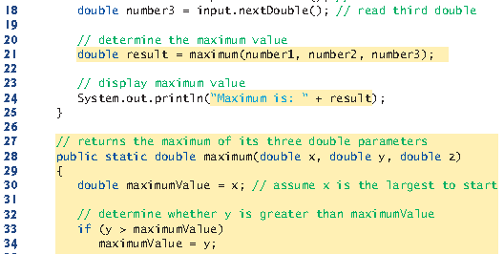

* **Conventions**

-Its a good practice to ensure, before you perform arithmetic calculations that they will not overflow. Same goes for dividing or calculating reaminder by 0.(to do this you simply check if divisor is 0.)

-When you multiply an integer with another integer assigning the result to a long is not enough. You have to cast one of them to long so the long result isnt truncated to int.

-Declare variables when they are needed not at the top.

* **Terms in Java**

**-Expression,** **Statement, Block:**

-Expression is a value made out of operands and operators.

-Statements instruct the computer to perform actions. The semicolon at the end of a line means that line is a statement. ; is called a statement terminator.

-Empty statement(null statement): Can be used with other control statemens too.

if( number1 == number2 ); // This would be interpreted by Java as

if( number1 == number2 )

; // Empty statement.

-Block: See if else notes.

**-Dot seperator:**

Class.method;

**-Expression:** Portions of statements that have values are called expressions.An expression is a syntactic construction that has a value. Expressions are formed by combining variables, constants, and method returned values using operators.

**-Declaration:** Reserves space.

int x;

**Initialization:** Assigns a value.

x = 10;

int x = 10; // Declaring and initializing at the same time.

**-Creation:** Ifwhat is gonig to be assigned not ready yet we need to create it. It can be an array, some sort of data structure of like a node or an object.

private Card[] deck; // Creation of reference to the array

deck = new Card[NUMBER_OF_CARDS]; // Creation of the array with 52 elements that have default values. Instantiating 52 card objects.

deck[count] = new Card(faces[count % 13], suits[count / 13]); // Creation of objects and initialization of array elements with references to these objects.

**-White space characters:** Blank lines, Space, Tab(\t), New line(\n).

**-Comments: Comments are deleted when the program in compiling so it doesn’t slow down the program.**

**-End of line comment: // This is an end of line comment**

**-Traditional comments: /* This is a traditional comment */**

-**Boxed comments**:

/********

* *

********/

-**Javadoc comments** enable you to embed program documentation directly in your programs. This way of embedding documentation is the conventional way of doing it. The javadoc utility proram generate HTML pages based on these comments.

/** documentation */

***Part 3***

* **Package:** Premade related classes are grouped into packages and are collectively referred to as Java class library or the Java Application Programming Interface( Java API). To put classes you write to the same package use the keyword package.

package packagename;

**-Classes in same directory = same package. Classes in same package dont need importing. They are implicitly imported.**

**-Import:** We use import to add classes that are not in our package to our program. Notice, we dont import classes under other packages in this package. We only import classes directly in this directory. When we import a class, we dont type its address compared to directory of our current class. We write imported class’s directory in src folder.

import packageName.ClassName;

-We cant import all packages in a folder,

import java.*;

We can import all classes in a package.

import java.util.*;

There is no package called java. Java is like a folder that holds packages.

-Fully qualified class name: You dont need to import classes if you are willing to type their full package name and class name every time.

Java.util.Scanner input = new java.util.Scanner(System.in);

**-** importjava.lang.System; is not needed because classes in it are automatically imported by class loader. Because it is the most essential class to run java programs. The predecessor of all classes object is inside it too.

java.lang is not the only implicitly imported package. The package the class is in is also implicitly imported.(in IDEs its the nameless package, default package). Importing classes from default package is a compile time error. You cant import a class from there because that package has no name.

So if we create a class A and call the constructor super() nothing will happen but if you call a constructor other than null it will give an error.

-Account class is in src\test folder while AccountTest class is in src folder. So we import Account class using import test.Account

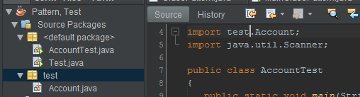

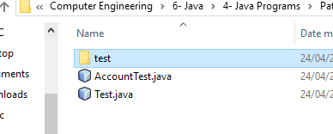

-Account class is in src\Source.testFolder and AccountTest class is in src folder. So we import Account class using import Source.testFolder.Account. (just like java.util.Scanner)

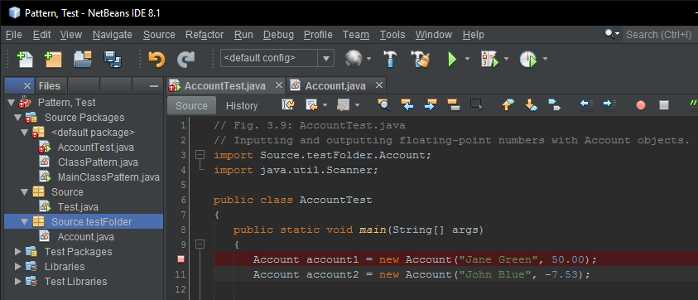

-Api of old java versions are called deprecated and might be removed from never versions. The compiler will warn you when you compile code that uses deprecated APIs. If you compile with javac using command line argument –deprecated, the compile will tell you which deprecated features you are using.

* **Introduction to Classes:** Every Java program consists of at least one class. Keyword class introduces a class declaration.

-We have to have a public class inside a .java file that has the same name as the .java file. For example if our .java file name is welcome1, we have to have a public class that has the name welcome1. This is the only public class in a .java file because there can only be one public class in a .java file.

-Driver class:When we have a class without main method, we need other class(es) that have main methods to use these classes from. Those classes are called driver classes.

-Client of a class: Other classes who create objects of this class and call the methods of this class.

-Static Object/Static Class: Static object in java is actually a class(it doesnt make sense to make an object static anyway. Static means you can access to it without creating an instance of it. So really what is static is methods and instance variables. Also you prevent the class from being instantiated.), all of whose members are declared static. It can be used in an application to provide global access to methods or variables. They can be used directly without creating objects for the static class, we can use them directly with: class_name.variable/method.

public class TestMyStaticClass {

public static void main(String []args){

MyStaticClass.setMyStaticMember(5);

System.out.println("Static value: " + MyStaticClass.getMyStaticMember());

System.out.println("Value squared: " + MyStaticClass.squareMyStaticMember());

// MyStaticClass x = new MyStaticClass(); // results in compile time error

}

}

// A top-level Java class mimicking static class behavior

public final class MyStaticClass {

private static int myStaticMember;

private MyStaticClass () { // private constructor

myStaticMember = 1;

}

public static void setMyStaticMember(int val) {

myStaticMember = val;

}

public static int getMyStaticMember() {

return myStaticMember;

}

public static int squareMyStaticMember() {

return myStaticMember * myStaticMember;

}

}

Why dont we just make the class/object non static and make its methods and fields static?

<https://stackoverflow.com/questions/7486012/static-classes-in-java>

<https://docs.oracle.com/javase/8/docs/api/java/lang/System.html#out>

<http://www.techrepublic.com/blog/software-engineer/using-the-singleton-pattern-in-java/>

* **Introduction to Methods:** Methods perform tasks and can return information when they complete their tasks.The parentheses near an identifier indicate it’s a method. Main is a method too and it has arguments too. The method header is the first line of a method where you specify method’s return type, name and parameter list parameter type and names. Calling a method is also referred to as invokinga method. Methods are generally public. Most methods must be called on a specific object.

objectName.methodName(arguments)

-Arguments and return values dont have to be primitive data types. They can be objects, enum constants. etc. Also arguments and return values may be constants, variables or expressions.

private enum Coin { HEADS, TAILS };

…

public static Coin flip()

public static void displayAccount(Account account1) {

System.out.printf("%s balance: $%.2f%n", accountToDisplay.getName(), accountToDisplay.getBalance());

}

…

Account.displayAccount(account1);

**-Main method**: Is the starting point of every Java application(it is always called automatically by JVM when you execute an application). There must be a main method in a java application and it must be defined as “public static void main( String[] args )” otherwise, the JVM will not execute the application. If a java class doesnt have main method than it is not an application. Program terminates when it reaches the end of main method. Main class/application class is the class that have the main method.

-A .java file doesnt have to have a class with main method(But then the program is not execuble. Instead it is a resource file, a header file etc.). Main method doesnt have to be in public class. We can have lots of classes in a .java file, only one of them can be public, main method can be in all of them and also one class can have multiple main methods but the main method we use with java command executes. (Even though you wrote the classes in the same .java file, all classes have their own .class file. So the main method of the .class file that is being executed is the one that is used.) You can overload main methods, that is you can change number or type of parameters which will be considered as a different method by the compiler since it has a different sign. Depending on the main method arguments, the correct main method will be chosen.

-In the Java programming language, every application(at least one class and at least one main method) must contain a main method whose signature is: ”public static void main(String[] args)”. It is public and static so JVM can access it and access it without instantiate an object of the class.

-Main method can have a return type. It can return an int by using System.exit(0); for example. Operating system interprets it.

**-Static method:** As we said before static methods and variables can be used without creating an object. In the example below our argument and parameter type is the class Account. As usual we have a type and a name.

public static void displayAccount(Account account1) {

System.out.printf("%s balance: $%.2f%n", accountToDisplay.getName(), accountToDisplay.getBalance());

}

…

Account.displayAccount(account1);

As you can see in the code above you can use object as argument/parameter.

-Setter and getter methods are used to set and get the values of instance variables safely. Predicate methods are used to get boolean values safely. Example below.

-When you are using a method inside it’s class, you dont have to specify what class. You just need to type the method’s name as you can see in the example below. Works both for main class and non main class.

public void setState(String state) {

this.state = state;

}

public String getState() {

return state;

}

public boolean isNoFaultState() {

boolean noFaultState;

switch (getState()) {

case "MA": case "NJ": case "NY": case "PA":

noFaultState = true;

break;

default:

noFaultState = false;

break;

}

* **Console Input/Output:**

**-System.out** object is predefined and known as the standart output object.

System -> class, out -> object of static class PrintStream(so only possible object of that class), printf -> method, (“...”) -> argument list, ; -> statement terminator.

<https://docs.oracle.com/javase/7/docs/api/java/lang/System.html>

<https://www.quora.com/What-is-the-purpose-of-a-static-object-in-Java-When-is-it-actually-used-or-in-which-context>

**-print, println, printf:** One string(argument to print methods) can’t span more than 1 line of code(all of the string has to be in one line) but you can use multiple strings in a print to divide things in a line to different lines in code and concatenate those strings.

**-**Print method displays a line of text in the command window. The text might go to the next

line(in cmd) if the text is big enough.

-Prntln puts a new line after printing.

**-**Printf(print formatted): We can print formatted without printf(using +). Or we can use printf. You cant use %n with println but the line seperator println uses at the end is portable across operating systems.

Printf’s first argument is a format string that may consist of fixed text, format specifiersandcontrol characters. Each format specifier is a placeholder for a value. We can also do the math inside printf (By using expressions instead of values/variables in non first arguments). Escape sequences in format string work but they dont work in fixed text.

-Outputs that lead user to take an action are called prompt.

**-**Newline Character and the line seperator:%n (a format specifier, the line seperator) only works with printf and is portable. \n (newline character) can be used with all three print methods but is not portable across OS, file processing, networking, etc.

Unix systems use newlines (\n) to mark line endings in text files. The MacOS uses carriage-returns (\r). Windows uses a carriage-return followed by a newline (\r\n).

<https://en.wikipedia.org/wiki/Newline>

-Blank line:System.*out*.println(“”);

-System.out.println( "Welcome to Java Programming!" );

-System.out.print( "Welcome to " );

System.out.println( "Java Programming!" );

-System.out.println( “Welcome to \nJava Programming!”);

-System.out.printf( “%s%n%s%n”, // These two rows are one statement.

“Welcome to ”, “Java Programming!”);

-System.out.printf( "Welcome to " // String concatenation

+ "Java Programming!" );

-System.out.printf( "%s%d%n%s%d%n", "Welcome to", aCount,

"Java Programming!", bCount);

-System.out.printf(“Sum is %d%n”, number1 + number2);

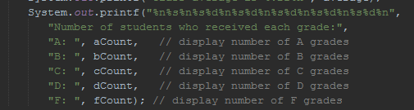

-We put + to sides of variables in formatted texts where there is a fixed string.

-System.out.println(i);

-System.*out*.println(name + “ “ + age);

-System.*out*.println("cadence: " + cadence + ", speed: " + speed);

-System.out.println("Population in " + year++ + ": " + (population *= growthRate));

-Formatting big numbers to make them easier to read:

-You can make big number more reable by using underscores. We can use this with values being displayed as binary, octal, hexadecimal too.

for (int roll = 1; roll <= 6_000_000; roll++)

long population = 0x7fff_ffff_ffffL;

-System.out.printf("Population in %d: %,d%n", year++, pop);

-System.out.println(String.format("%,d", pop));

-System.out.println(String.format("%,d", pop).replace(",", " "));

-Scientific notation:

- float number = 3.30e23; // 3.30 * 1023

- float number = 6.67e-11; // 6.67 * 10-11

**-String concatenation:**

-Java allows you to assemble String objects into larger strings by using operators +, += or concat(String) (is this an operator or a method?).

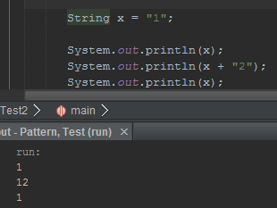

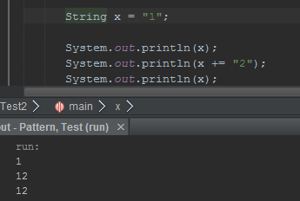

The + takes the strings literals/variables or other literals/variables in both sides and merges them in a new temporary string that gets collected by garbage collector later. toString method is called implicitly if needed for non string variables(including objects).

The += takes the string literal/variable in the right side and adds it to the string variable in the left side. Left side must be a string variable.

This is known as string concatenation. When both operands of operator + are String objects,

operator + creates a new String object in which the characters of the right operand

are placed at the end of those in the left operand.

Every primitive value and object in Java can be represented as a String. When one of the + operator’s operands is a string, the other is converted to a String, then the two are concatenated.

If there are any trailing zeros in a double value, these will be discarded when the number is converted to a String—for example 9.3500 would be represented as 9.35.

A boolean concatenated with a String is converted to the String "true" or "false". All objects have

a toString method that returns a String representation of the object.

It’s a syntax error to break a String literal across lines. If necessary, you can split a String

into several smaller Strings and use concatenation to form the desired String. You can break large String literals into several smaller Strings and place them on multiple lines of code for readability. In this case, the Strings can be reassembled using concatenation.

-Confusing the + operator used for string concatenation with the + operator used for addition

can lead to strange results. Java evaluates the operands of an operator from left to right. For example, if integer variable y has the value 5, the expression

"y + 2 = " + y + 2

results in the string "y + 2 = 52", not "y + 2 = 7", because first the value of y (5) is concatenated to the string "y + 2 = ", then the value 2 is concatenated to the new larger string "y + 2 = 5". The expression "y + 2 = " + (y + 2) produces the desired result "y + 2 = 7".

Be aware that following code outputs “4 + 1 = 41” for the inputs 4 and 1.

System.out.print(no1 + " + " + no2 + " = " + no1 + no2);

There are 5 + operators(the ones in string is a character not an operator). These work left to right. So when 4th + mixes left side and right side it has a string on the left, 5th operator has a string on the left operand too. So we end up not doing any math at all. In order to fix this problem use paranthesis.

System.out.print(no1 + " + " + no2 + " = " + (no1 + no2));

**-Formatting Output:**

-Printing a table: Print the first item of the table header. To allign first column of other rows use width of first column of table header. So in our example above it’s four.

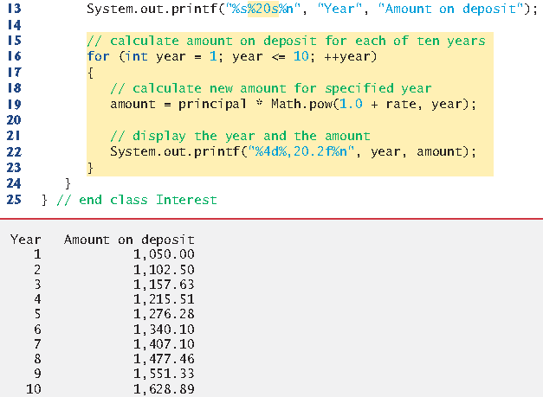



- The integer 20 between the % and the conversion character s indicates that the value should be displayed with a field widthof 20—that is, printf displays the value with at least 20 character positions. If the value to be output is less than 20 character positions wide (17 characters in this example), the value is right justifiedin the field by default. If the year value to be output were more than four character positions wide, the field width would be extended to the right to

Accommodate the entire value—this would push the amount field to the right, upsetting

the neat columns of our tabular output. To output values left justified, simply precede the

field width with the minus sign (–) formatting flag(e.g., %-20s).

- %,20.2f. The comma (,) formatting flagindicates that the floating-point value should be output with a grouping separator. The actual separator used is specific to the user’s locale (i.e., country). For example, in the United States, the number will be output using commas to separate

every three digits and a decimal point to separate the fractional part of the number, as in

“1,234.45”. The number 20 in the format specification indicates that the value should be

output right justified in a *field width* of 20 characters. The .2 specifies the formatted number’s

*precision*—in this case, the number is *rounded* to the nearest hundredth and output

with two digits to the right of the decimal point. By default, floating-point values are displayed with six digits precision.





- %020d. 20 means the same thing as above but the 0 before that is called the 0 flag(tag: zero flag) and it displays a leading 0 for values with fewer digits than the field width.

- %+d puts a “+” in front of the value.

- Floating point values can be showed to look like integers by printing them with no digits after floating point(%.0f). But this is not recommended both when you are printing and when you are writing source code. Users and devs should know its a floating point value.

- A Warning about Displaying Rounded Values: Here’s a simple explanation of what can go wrong when using double (or float) to represent dollar amounts (assuming that dollar amounts are displayed with two digits to the right of the decimal point): Two double dollar amounts stored in the machine could be 14.234 (which would normally be rounded to 14.23 for display purposes) and 18.673 (which would normally be rounded to 18.67 for display purposes). When these amounts are added, they produce the internal sum 32.907, which would normally be rounded to 32.91 for display purposes. Thus, your output could appear as

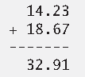

but a person adding the individual numbers as displayed would expect the sum to be

32.90.

Do not use variables of type double (or float) to perform precise monetary calculations.

The imprecision of floating-point numbers can lead to errors. How to use integers to perform precise monetary calculations—Java also provides class java.math.BigDecimal for this purpose.

**-System.in** object is predefined and known as the standart input object.

<https://docs.oracle.com/javase/7/docs/api/java/lang/System.html>

**-Scanner**(import java.util.Scanner;): System.in allows program to read byte sized data inputted by user. The “next…” methods turn those byte sized data into Java data types.

-You should check if the value entered is in type you want and in format/range you want. Telling user what they need to enter clearly, validating, range checking, re-asking when wrong value is entered are important parts of programming.

-**nextLine:** Pressing enter puts a newline character after the characters you typed. When you press enter characters are read by the method until it encounters newline and returns a string conatining character up to but not including newline, which is discarded.

-Extra newline character: NextLine reads the value you type and the newline character. Non NextLine readers dont absorb the newline character. So if you used a non NextLine, you need to absorb its newline character with a next or nextLine method. And after this you can read a text again with next or nextLine. You only need to use one next method for the last extra newline character in the keyboard buffer. C uses fflush method in stdio library for th’s purpose.

You dont need to get rid of the extra newline character when you are readin the next int or double etc. because they ignore the newline character and only read what they are looking for.

scan.nextLine();

String s = scan.nextLine();

String s = scan.nextLine();

if(scan.hasNextLine() || s.isEmpty()){

s = scan.nextLine();

}

-**next:** Reads the next word/ When you press enter after typing some text, method next read characters until it encounters a white space character, then returns a string containing characters up to, but not including the white space character which is discarded.

Scanner input = new Scanner(System.in);

  int a, b;

  a = input.nextInt();

  b = input.nextInt();

int a, b; // First way of declaring variables.

int a, // Second way of declaring variables.

b;

int a; // Third way of declaring variables. This one is the convention.

int b;

-You dont have to assign a value to a variable and then use that variable. You can just use a variable you get from the user directly for one time.

-if (input.nextInt() == 0)

-setName(input.nextLine())

* **Object Oriented Programming**

**-Creating Classes and objects:** Creatingan object of a classis called Instantiation. Objects are instances of a class. Each new class you create becomes a new type that can be used to declare variables and create objects (Account: type, account1: reference variable, the object referenced by the reference variable account1: object). You can declare new classes to fit your needs whenever you want. Thats why java is an extensible language.

-There are different ways to customize instance variables.

1. With constructor.
2. Directly(if you have permission to)

Station1.name = miami;

1. Use the set method

station.setname(miami);

-To customize methods you use interfaces because inherited methods are unchanged(unless overridden).

public class Account // class declaration

Bicycle bike1 = new Bicycle(); // object declaration

Test test1; // declaration

test1 = new Test(); // assigment

**­ -New:** The keyword new allocates memory for the object. (Requests for space from the system.) The constructor to the right of keyword new which creates the object is called implicitly by the keyword new. Address of the created object(result of right variable, which is an expression) is assigned to the left variable (which is a reference variable with a name and a type specified) using the assign operator. “new Account()” is called “class instance creation expression”.

Account account1 = new Account(“Jane Green”); // This line creates and initializes object account1. Account one is a reference variable that holds address of an Account type object. Right side is the class instance creation expression. It gets the memory for the object and creates it and returns the address.

**Variable Types**

A variable is alocation in computer’s memory where a value can be stored for use later in a program. Variables refer to the memory location where the value is stored. Programs remember numbers and other data in the computer’s memory and access that data through program elements called variables. All java variables must be declared with a name and type before they can be used. All variables have a name, type, size and a value. A variable’s name enables the program to access the value of the variable in memory. Destructive process is a process that causes some data to be lost(writing). Non destructive process is a process that doesnt cause data to be lost(reading).

For primitive types the variable name holds the address to a memory in stack where the value is kept.

**-Value vs Reference:** Value of a variable(both primitive and reference) mean their actual data. Reference means the address, reference type variables hold in stack that shows the adress of actualy value(object) in heap.

**-Primitive types:**

-Primitive types are int, boolean, byte, char, short, long, float and double. All non primitive types are reference types so classes which specify types of objects are reference types. A primitive type can hold one value at a time. You can initialize primitive types yourself by giving them a value at declaration(which is called initialization).

**-Stack, Heap:** Primitive type variables are kept at stack.

**-Reference types:**

-Programs use reference type variables(called references) to store adresses of objects in computer’s memory. Such a variable is said to refer to an object in the program. To call methods on an object, you need a reference to the object(myAccount.getName). So we can use reference type variables to refer to call methods not primitive type variables. Reference type variables dont refer to object’s contents. It instead refers to a chunk of memory that contains the object’s contents. Default value for reference type variables is “null” which means the pointer is not pointing to anything.

int[] array = null;

**-Stack, Heap:** Reference data types(pointers) are held at stack. The memory they point to is at heap just like C#.

referenceVariable = null; means it doesnt point to anything anymore. New is responsible for data allocation. The address of memory we allocated is assigned to the reference variable left of equals operator.

More stack-heap information in array notes.

<http://net-informations.com/faq/net/stack-heap.htm> (tag: stack frame, method call stack)

**-Object:** Objects are instances of classes. They hold a memory in heap. They have an address in heap. Their default value is null. When garbage collector runs, it deletes the objects that no reference variables reference to.

**-Garbage Collector:** Every object uses system resources, such as memory. We need a disciplined way to give resources back to the system when they’re no longer needed; otherwise, “resource leaks” might occur that would prevent resources from being reused by your program or possibly by other programs. The JVM performs automatic garbage collection to reclaim the memory occupied by objects that are no longer used. When there are no more references to an object, the object is eligible to be collected. Collection typically occurs when the JVM executes its garbage collector, which may not happen for a while, or even at all before a program terminates. So, memory leaks that are common in other languages like C and C++ (because memory is not automatically reclaimed in those languages) are less likely in Java, but some can still happen in subtle ways. Resource leaks other than memory leaks can also occur. For example, an app may open a file on disk to modify its contents—if the app does not close the file, it must terminate before any other app can use the file.

So close your streams, files and other I/O classes when you are done using them.

input.Close(): // Closing Scanner object.

-Lets say you create two objects named e1 and e2 of class Employee. When main terminates, local variables e1 and e2 are discarded—remember that a local variable exist only until the block in which it’s declared completes execution. Because e1 and e2 were the only references to the Employee objects created in lines 13–14 (Fig. 8.13), these objects become “eligible for garbage collection” as main terminates.

Garbage collector might eventually reclaim the memory for any objects that are eligible for collection. If any objects are not reclaimed before the program terminates, the operating system will reclaim the memory used by the program. The JVM does not guarantee when, or even whether, the garbage collector will execute. When it does, it’s possible that no objects or only a subset of the eligible objects will be collected.

There are two ways garbage collector could know an object has no references pointing it. Either objects have counters or garbage collectors looks at references in and sees if any object have no references.

**-Finalize:** Never use the method of Class object”finalize”. Does some explaining in page 280 but will Object class explain more in ch 9 and finalize more in section 11.12

input.close();

**-Instance Variable, Class Variable (Field):**

-You dont have to initialize them. They have default values. Class loader and JIT compiler initializes fields to their default values not constructors.

-If you dont assign them a value, deafult value is assigned. Ise constructors to assign value during object creation.

-Declared inside class but outside methods.

-These are used to represent attributes of a type.

-Its scope depends on its adornment. (Scope vs accesibility)

-Fields exists as long as the object exists.

-Most insance variable declarations are preceded with private keyword so the variable can only be used by methods of its own class.

-You can use instance variables of an object in that object’s methods.

-Instance variables allow objects to have their own variables.

-Scope of fields and methods is their class. Importing is needed outside.

-Make all instance methods private. If you need a variable that is constant and needs to be reached from outside use public static final.

Class A {

int hour;

void setTime(int h) {

hour = h;

}

}

**Instance variable:** Non static variables of objects. Every instance has its own copy.

**Class variable:** Static variables of classes. Shared for all objects and class.

**Field:** Instance variable + class variable = field.

-Member: field + methods.

**-Local Variable**:

-You have to declare them before you use them. If it needs to have a value when it is first used then you have to assign a value yourself.

- It doesnt have a default value for when you dont initialize it.

-Declared inside a method or constructor or a repetition statement.

-These are used to store information(state) temporarily.

-Can only be used in their block they were declared in(they can be used from the line they are declared until end of their scope. (they are known inside their block which could be a method, constructor, loop, if-else) Each method(including constructors and main) can access to only its local variables. But loop statements, if-else statements can use local variables that are declared outside them in the same method/constructor.

-Local variables exists until their scope ends.

**-Argument:** Arguments are the values we use while invoking a method. These values are passed to the variables in method called parameters.

**-Parameter:** You declare them in the parameter list. They are initialized with arguments. Argument number has to be equal to parameter number. Types dont have to be same as we will see later but they have to be compatible. You have to specify a type and a name for each parameter.

**-Adornments(Access modifiers):** Access modifier determines which scopes can access classes, methods and instance variables.

**-Public(+):** Can be reached from all packages in the project.

**-Protected(#):** Can be reached from own class, package, other package subclass.

**-no modifier:** Can be reached from own class, package.

**-Private(-):** Can be reached from own class.

-Classes are generally public or default. (Only nested and inner nested classes can be protected or private.)

-But instance variables and methods can use any of the four access modifier.

-Generally instance variables are private. So you cant access them directly from outside class. You need to use public methods of that class to access those variables you dont have access to.

myAccount.name = "test"; // If name is public you can access it from other classes like this

String theName = input.nextLine();

myAccount.setName(theName); // This is how you access private instance variables.

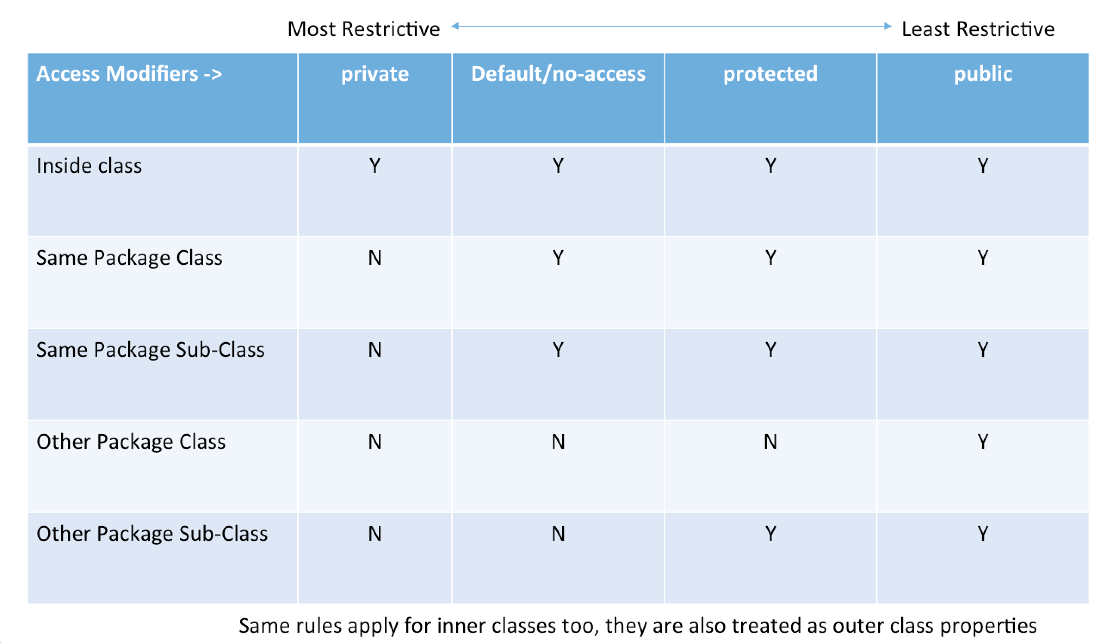

-World: Other packages(directories).

-No modifier is also called package private or package access.

-Public methods are also called public services or public interface. Private methods are also called utility methods or helper methods.

**-Scope:** The scope of a declaration is the portion of the program that can refer to the declared entity by its name.

**1.** The scope of a parameter declaration is the body of the method in which the declaration

appears.

**2.** The scope of a local-variable declaration is from the point at which the declaration

appears to the end of that block.

**3.** The scope of a local-variable declaration that appears in the initialization section

of a for statement’s header is the body of the for statement and the other expressions

in the header.

**4.** A method or field’s scope is the entire body of the class. (non private? Pg 265)

-Also look at “-Accessing to Methods and Fields” section of second method notes.

**-Principle of Least Privilege:** In a general sense, “things” should have the capabilities they need to get their job done, but no more. An example is the scope of a variable. A variable should not be visible when it’s not needed. Or if the variable doesn’t need to change after initialization we should make it final.

**-Setter, Getter**

**-Safety in set and get methods:** It isnot safe to give direct access to instance fields. You might think set and get methods dont change anything security wise since you still read or write anything you want just through methods. But set and get methods are supposed to have controls that let you only read and write certain types of values in certain ways. This makes our code mroe robust and strong.

-Declaring instance variables with private access modifier is known as data hiding(restricting scope something can be reached from).

-When a program creates an object of a class, instance variables are encapsulated(hidden and also related data and methods are bundled)in the object and can be accesses only by methods of object’s class.

**-Setter:**

-Commonly called mutator methods.

-We are be able to directly assign values to instance/class variables when they are not private.

-Usually setter methods have void return type, use exception handling to prevent and indicate attempts to assign invalid data.

station1.location = miami;

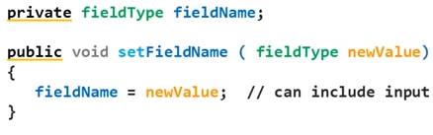

public void deposit(double depositAmount) {

if (depositAmount > 0,0)

balance = balance +depositAmount;

}

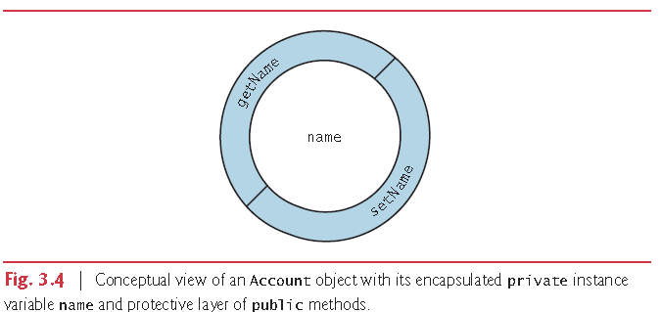

(tab: *encapsulation*, data hiding)

**-Getter:** The method knows which object’s variables to manipulate because we call it via reference variable (object) –> object.method().

-Commonly called accessor methods or query methods.

-Use return this.variableName.

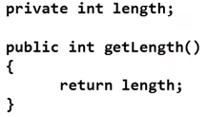

**-Static:** Static variables and static methods are shared among the class and its objects. Static class members and static methods exist and can be used even when no objects of the class have been instantiated. They are avaiable as soon as the class is loaded into memory at execution time. (static main method is an example to this)

Static methods are generally frequently used methods. A static method is called by using its class name followed by a dot seperator and the method name.

“ClassName.methodName(arguments)”

-You cant refer to “this” in a static method.

-Using static variables instead of giving the same instance variable to all object saves time and memory and more error resistant. Using static methods doesnt save time and memory because java already hold only one copy of methods. More information about this in ch8 notes. (add link here later)

**-This:** Sometimes called this reference.You canuse the instance variable/class variable directly if there is no local variable with the same name. If there is a local variable with the same name the field variable gets shadowed. So you need to use this.variableName to access the field variable.

-We cant use this when we are in a static method.

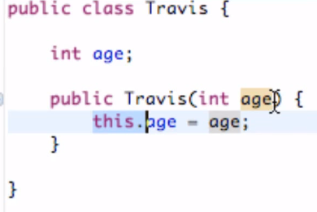

-First function of implicit and explicit this reference is using class’s or instance’s variable instead of the method’s. If we didnt have this reference in the code above it would use implicity this reference.

class OuterClass {

void method() { }

class InnerClass {

void method() {

OuterClass.this.method(); // not the same as method().

}

}

}

-Second function of explicit this is it lets you use the method and variables of ‘this’ class, not the class we are in right now.

-this.variable; name and this.methodName(parameter list); are used to access instance variables and instance methods of a class. But to access constructors you use this(parameter list);

Add more notes when you study 8. 9. 10. chapters

**-Variable shadowing:** If two variables have the same name in a method(one local one field) the local one is used. In this case the local variable shadowed the field variable. If we use “this” then field shadows local. When you use the field variable the changes you make to the instance variable are made to the actual field variable and are permanent.

**-Constructor:** Each class you create can optionally provide constructors with parameters that can be used to initialize an object of a class when the object is created with user input or the values we decide. So constructors are used to initialize variables that can be initialized at the creation of the object.

**-**Java requires a constructor call for every object that is created(even if you didnt create a constructor, there are implicit constructors provided by compiler. If you declare a constructor yourself then there is no default constructor. If there is no default constructor that means you cant create object with default constructor(“new Account()”) unless you create one yourself.

**-**Constuctor is not what initializes instance variables to default values of their types.

**-**Constructors cant have return types, not even void. They are generally public. They cant be called, they are automatically called when you create an object.

public Account(String name) {

this.name = name;

}

public Account(String name, int age) { // Constructors can be overloaded

this.name = name;

this.age = age;

}

-Constructors must have the same name as the class. A constructor will have a parameter list. When you create a new object with parameters of a specific constructor, that constructer will execute, the arguments you entered will be passed to constructor’s parameters and from there it will be used to initialize instance variables etc.

-Java allows other methods of the class besides its constructors to have the same name as the class and to specift return types. Such methods are not constructors and will not be called when an object of the class is instantiated.

-Should you copy the code of set methods into constructor? Should you call set methods from constructor? It depends on implementation of the program you are working on and how reliable the data is. If the data is coming from your own already controlled database you might want to directly take it.

-You can call methods from constructors but you shouldnt. This will be explained in chapter 10. Fields not initialized yet. Can cause problems.

* **Logical operators, Decision making:**

**-Condition:** Is an expression that can be “true” or “false”. In java -unlike C languages- your condition expressions must be boolean.

-Things you can use as a condition:

- true

- false

- A boolean type variable

- A simple condition(2 operands and either a relational operator or an equality operator) or a complex condition(simple conditions merged using && or || or ^).

-You can use ! to reverse value of expressions/variables that have boolean type.

- if (!(grade == sentinelValue))

- if (!boolean1)

- if, if…else, while, do…while, for and switch statements each require a condition to determine how to continue a program’s flow of control. Simple conditions are expressed in terms of the relational operators >, <, >= and <= and the equality operators == and !=, and each expression tests only one condition. To test multiple conditions in the process of making a decision, we performed these tests in separate statements or in nested if or if…else statements. Sometimes control statements require more complex conditions to determine a program’s flow of control.

- Java’s logical operatorsenable you to form more complex conditions by combining

simple conditions. The logical operators are && (conditional AND), || (conditional OR), &

(boolean logical AND), | (boolean logical inclusive OR), ^ (boolean logical exclusive OR)

and ! (logical NOT). Note: The &, | and ^ operators are also bitwise operators when they’re

applied to integral operands.

Example: (x % 2); // if x is multiple of 2, true(1), not multiple of 2, false(0)

-De morgan theorem: These laws state that the expression !(condition1 && condition2) is logically equivalent to the expression (!condition1 || !condition2).

**-Conditional operators**

**-Condtional AND(&&) Operator:** Suppose we wish to ensure at some point in a program that two conditions are both true before we choose a certain path of execution. In this case, we can use the && (conditional AND) operator, as follows:

if (gender == FEMALE && age >= 65)

++seniorFemales;

The if statement considers the combined condition is true if and only if *both* simple conditions are true.

Some programmers find that the preceding combined condition is more readable when *redundant* parentheses are added, as in:

if((gender == FEMALE) && (age >= 65))

**-Conditional OR(||) Operator:** Now suppose we wish to ensure that *either or both* of two conditions are true before we choose a certain path of execution. In this case, we use the **||** (conditional OR) operator, as in the following program segment:

if ((semesterAverage >= 90) || (finalExam >= 90))

System.out.println ("Student grade is A");

This statement also contains two simple conditions.

-Short Circuit evaluation of complex conditions: The parts of an expression containing && or || operators are evaluated *only* until it’s known whether the condition is true or false. Thus, evaluation of the expression

(gender == FEMALE) && (age >= 65)

stops immediately if gender *is not* equal to FEMALE (i.e., the entire expression is false) and

continues if gender *is* equal to FEMALE (i.e., the entire expression could still be true if the

condition age >= 65 is true). This feature of conditional AND and conditional OR expressions

is called short-circuit evaluation.

-Problem with this feature is if we have a statement such as

if (a < b) && (++c < 10)

the c variable wont be incremented. Such dense coding style is not recommended. ++c expression is called side effect denilir. Using “boolean and” or “boolean or” will prevent this error. Or we can use dependant condition.

-In expressions using operator &&, a condition—we’ll call this the dependent condition— may require another condition to be true for the evaluation of the dependent condition to be meaningful. In this case, the dependent condition should be placed after the && operator to

prevent errors. Consider the expression (i != 0) && (10 / i == 2). The dependent condition

(10 / i == 2) must appear after the && operator to prevent the possibility of division by zero.

**-Boolean Logical AND (&) and Boolean Logical Inclusive OR (|) Operators:** The boolean logical AND (&) and boolean logical inclusive OR (|) operators are identical to the && and || operators, except that the & and | operators always evaluate both of their operands (i.e., they do not perform short-circuit evaluation).

-This is useful if the right operand has a required side effect.

-Dont use side effect in your code.

**-**Assignment (=) expressions generally should not be used in conditions. Every condition must result in a boolean value; otherwise, a compilation error occurs. In a condition, an assignment will compile only if a boolean expression is assigned to a boolean variable.

**-Boolean Logical Exclusive OR (^):** A simple condition containing the boolean logical exclusive OR (^) operator is true if and only if one of its operands is true and the other is false. If both are true or both are false, the entire condition is false.

This operator is guaranteed to evaluate both of its operands.

**-Logical Negation (!) Operator:** The **!** (logical NOT, also called logical negationor logical complement) operator “reverses” the meaning of a condition. Unlike the logical operators &&, ||, &, | and ^, which are *binary*operators that combine two conditions, the logical negation operator is a *unary* operator that has only one condition as an operand.

if (! (grade == sentinelValue))

System.out.printf("The next grade is %d%n", grade);

In most cases, you can avoid using logical negation by expressing the condition differently

with an appropriate relational or equality operator. For example, the previous

statement may also be written as follows:

if (grade != sentinelValue)

System.out.printf("The next grade is %d%n", grade);

* **Algorithms**

-See “Algorithm Notes” and “UML Notes” file for this information.

* **Structured Programming**

**-Control Structures in Structured Programming:** Normally statements in a program are executed one after the other in the order in which they are written. This process is called sequential execution. Using various statements to specify the next statement to execute is called transfer of control.

The term Control structures comes from the field of computer scence. *The Java Language Specification* refers to “control structures” as “control statements”.

- During the 1960s, it became clear that the random use of transfers of control

was the root of much difficulty experienced by software development groups. The blame

was pointed at the goto statement (used in most programming languages of the time),

which allows you to specify a transfer of control to one of a wide range of destinations in

a program. [Note: Java does not have a goto statement; however, the word goto is reserved

by Java and should not be used as an identifier in programs.]

The research of Bohm and Jacopini had demonstrated that programs could be

written without any goto statements. The challenge of the era for programmers was to shift

their styles to “goto-less programming.” The term structured programming became

almost synonymous with “goto elimination.” Not until the 1970s did most programmers

start taking structured programming seriously. The results were impressive. Software

development groups reported shorter development times, more frequent on-time delivery

of systems and more frequent within-budget completion of software projects. The key to

these successes was that structured programs were clearer, easier to debug and modify, and

more likely to be bug free in the first place.

Bohm and Jacopini’s work demonstrated that all programs could be written in terms

of only three control structures/control statements; the sequence structure, the selection structure and the repetition structure.   
-Controlling expression is the expression that gives the value to control statement and control statement works depending on that value.

**-Sequence Structure:** The sequence structure is built into Java and other modern programming languages. Unless directed otherwise, the computer executes Java statements one after the other in the order in which they’re written—that is, in sequence. Java lets you have as many actions as you want in a sequence structure. Anywhere a single action may be placed, we may place several actions in sequence.

-**Selection Structure:** Java has three types of selection statements The *if statement* either performs an action if a condition is *true*, or skips it if the condition is *false*. The *if*…*else statement* performs an action if a condition is *true* and performs a different action if the condition is *false*. The *switch statement* performs one of *many* different actions, depending on the value of an expression.

The if statement is a single-selection statement because it selects or ignores a *single*

action (or, as we’ll soon see, a *single group of actions*). The if…else statement is called a

double-selection statement because it selects between *two different actions* (or *groups of*

*actions*). The switch statement is called a multiple-selection statement because it selects

among many different actions (or groups of actions).

**-Repetition Structure:** Java provides three repetition statements (also called iteration statements or looping statements) that enable programs to perform statements repeatedly as long as a condition (called the loop-continuation condition) remains *true*. The repetition statements are the

while, do…while, for and enhanced for statements. The while and for statements perform the action (or group of actions) in their bodies zero or more times—if the loop-continuation condition is initially *false*, the action (or group of actions) will *not* execute. The do…while statement performs the action (or group of actions) in its body *one or more* times.

-Calculations: In loops, avoid calculations for which the result never changes—such calculations should typically be placed before the loop. Many of today’s sophisticated optimizing compilers will

place such calculations outside loops in the compiled code.

**-Counter controlled repetition:** Counter controlled repetition does the action one at a time(for example inputting numbers to calculate average) instead of taking them all at the same time(isn’t this true for both?). We have a counter(control variable) to control the number of times a set of statements will execute. Counter controlled repetition is often called definite repetition because the number of repetition is known before the loop begins executing.

-Elements of counter controlled repetition;

-Control variable

-Initial value

-Increment

-Loop continuation condition

-Floating point variables are approximate so you shouldnt use them as counters. Use integers instead.

- This code saves a statement, Coding in such a condensed fashion takes practice, might make code more difficult to read, debug, modify and maintain, and typically should be avoided.

int counter = 1;

while (counter++ <= 10) // loop-continuation condition

System.out.printf("%d ", counter);

**-Sentinel controlled repetition:** In definite repetition we knew how many times the loop was going to execute. But in this case we dont know how many times the loop is going to work. The loop is going to execute until sentinel value is entered.

-This repetition uses a special value called a sentinel value(also called a signal value, sentinel, a dummy value or a flag value) to indicate “end of data entry.” The user enters grades until all legitimate grades have been entered. The user then types the sentinel value to indicate that no more grades will be entered. Sentinel-controlled repetition is often called indefinite repetition because of the number of repetitions is not known before the loop begins executing.

-Clearly a sentinel value must be chosen that cannot be confused with an acceptable input value.

-We read the first value and test it before the while statement to see if we will go into repetition at all when we use sentinel controlled repetition. The last thing we do in while body is reading the new value so we can test it with head of while statement.

-In sentinel controlled loops you should prompt the sentinel value to user.

**-Nested control statements:** We have seen that control statements can be stacked(sequence), they can be nested too(putting control statements inside loops is considered nesting). Stacked meant they work one after another. Loop meant they keep doing executing same block of code until condition is true. Nested means code blocks works inside other code blocks.

while {

if {

}

}

-**Structured programming summary:** Java has only three kinds of control structures, which from this point forwards we refer to as control statements: the sequence statement, selection statement, repetition statement. Every program is formed by combining as many of these statements as is appropriate for the algorithm the program implements.

Statement blocks running one after another passing values is called control statement stacking.

When control statements are inside one another we call that control statement nesting.

So algorithms in java programs are constructed from only these tree kinds of control statements, combined in only two ways(repetition is counted as nested). This is the essence of simplicity.

-For simplicity Java includes Single-entry/single-exit control statements. Which means, a piece of program starts from one place and returns to one place. You can stack these pieces or nest them. (See uml diagrams at pages 225-228)

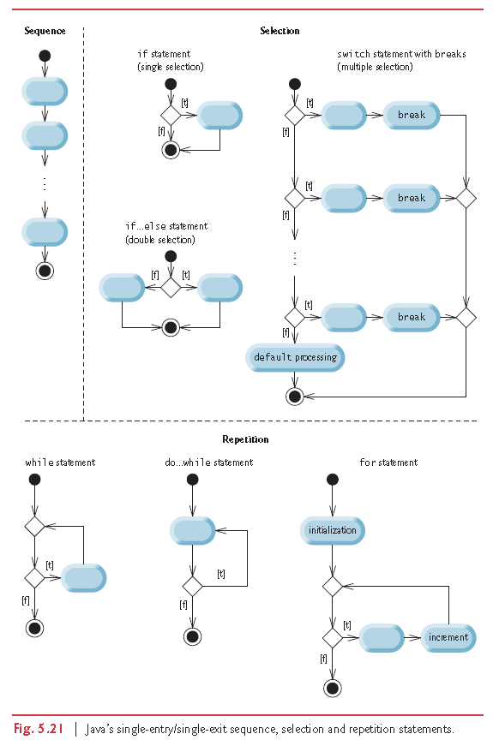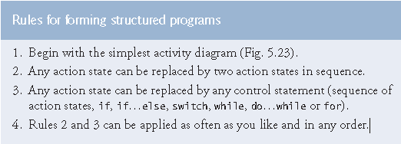

Applying the rules always results in a properly structured activity diagram with a neat, building-block appearance. For example, repeatedly applying rule 2 to the simplest activity diagram results in an activity diagram containing many action states in sequence. Rule 2 generates a *stack* of control statements, so let’s call rule 2 the stacking rule. The vertical dashed lines are not part of the UML—we use them to separate the four activity diagrams that demonstrate rule 2 being applied.

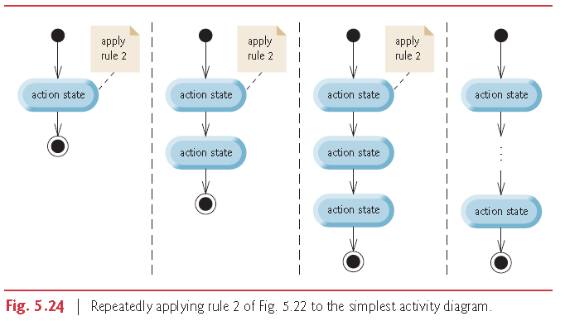

Rule 3 is called the nesting rule. Repeatedly applying rule 3 to the simplest activity diagram

results in one with neatly *nested* control statements. For example, in Fig. 5.25, the

action state in the simplest activity diagram is replaced with a double-selection (if…else)

statement. Then rule 3 is applied again to the action states in the double-selection statement,

replacing each with a double-selection statement.

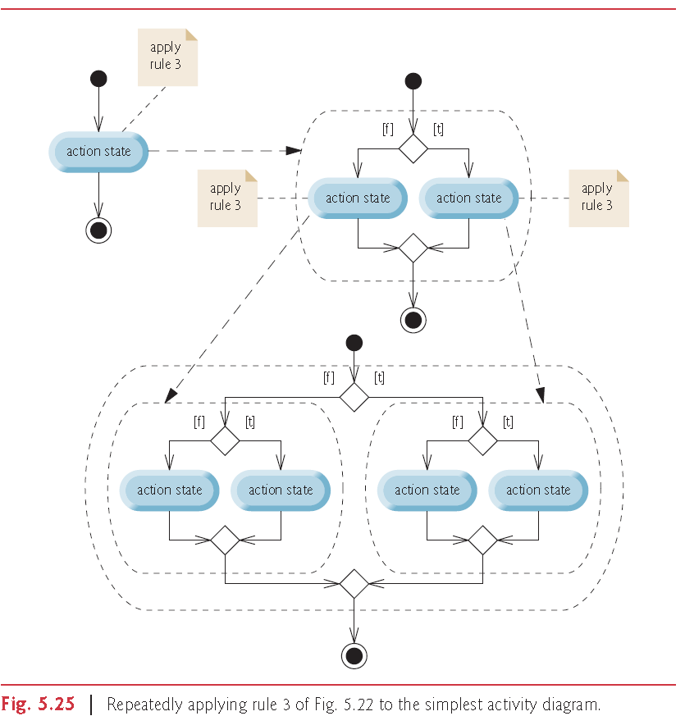

Rule 4 generates larger, more involved and more deeply nested statements. The diagrams

that emerge from applying the rules constitute the set of all possible

structured activity diagrams and hence the set of all possible structured programs. The

beauty of the structured approach is that we use *only seven* simple single-entry/single-exit

control statements and assemble them in *only two* simple ways.

If the rule are followed, an “unstructured’ activity diagram (like the one in Fig. 5.26) cannot be created. If you’re uncertain about whether a particular diagram is structured, apply the rules in reverse to reduce it to the simplest activity diagram. If you can reduce it, the original diagram is structured; otherwise, it’s not.

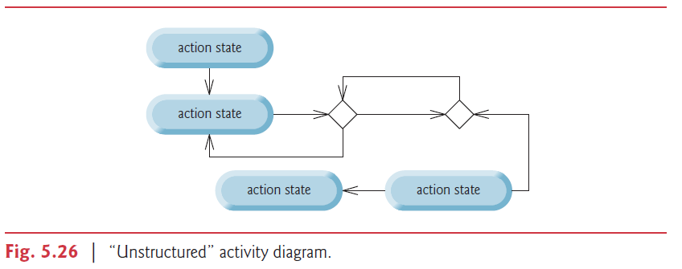

Structured programming promotes simplicity. Only three forms of control(control statements) are needed to implement a structured algorithm:

- sequence

- selection

- repetition

-The sequence structure is trivial. Simply list the statements to execute in the order in which they should execute.

-Selection is implemented in one of three ways:

- if statement (single selection)

- if…else statement (double selection) (conditional statement is same as if else)

- switch statement (multiple selection)

In fact, it’s straightforward to prove that the simple if statement is sufficient to provide

*any* form of selection—everything that can be done with the if…else statement and the

switch statement can be implemented by combining if statements (although perhaps not

as clearly and efficiently).

-Repetition is implemented in one of three ways:

- while statement

- do…while statement

- for statement

- enhanced for

It’s straightforward to prove that the while statement is sufficient to provide

*any* form of repetition. Everything that can be done with do…while and for can be

done with the while statement (although perhaps not as conveniently).

Combining these results illustrates that *any* form of control ever needed in a Java program

can be expressed in terms of these 7 form of control and that these can be combined in only two ways(stacking and nesting). Indeed, structured programming is the essence of smplicity.

**-Top-down stepwise refinement:** Techniques to form out algorithm is needed for well structured programs.Top-down technique means we start from the biggest problem(whole software) and we break it into small pieces. Down-top approach is the opposite. Starts from small parts and works its way to whole software. Stepwise refinement stands for these steps we take from whole software to small pieces of from small pieces to whole software. Lets give an example to a “top” which is a single statement that conveys the overall function of the program.

“Determine the class average for the quiz”

The top rarely conveys sufficient detail from which to write a java program. So we now begin the refinement process. We divide the top into a series of smaller tasks and list these in order in which they will be performed. This results in the following first refinement. The example below only uses sequence structure.

Initialize variables

Input, sum and count the quiz grades

Calculate and print the class average

-Each refinement as well as the top itself is a complete specification of the algorithm. Only the level of detail varies.

-Many programs can be divided logically into three phases. An initialization phase that initializes variables. A processing phase that inputs data values and adjuts program variables accordingly. And a termination phase that calculates and outputs the final results.

In the second refinement we commit to specific variables. For our quiz example, the first pseudocode statement can be refined as:

Initialize total to zero

Initialize counter to zero

We initialize only the variables that needs it. Some variables will receive values so they dont need values at the start.

For the second statement of our first refinement, we use sentinel controlled repetition because we dont know how many grades will be entered.

Prompt the user to enter the first grade

Input the first grade(possibly the sentinel)

While the user has not yet entered the sentinel

Add this grade into the running total

Add one to the grade counter

Prompt the user to enter the next grade

Input the next grade(possibly the sentinel

-In pseudocode we do not use braces around the statements that form the body of the while structure. Instead we indent.

The last statement in our first refinement can be refined again as:

If the counter is not equal to zero

Set the average to the total divided by the counter

Print the average

“Else”

“Print “No grades were entered”

-Blank lines seperate the algorithms into their phases and set off control statements; the indentation emphasizes the bodies of the control statements.

-Terminate the top-down stepwise refinement process when you have specified the pseudocode algorithm in sufficent detail for you to convert the pseudocode to java. Normally implementing the java program is then straightforward.

**-Conditional Control Statements**

-**if**: An if statement expects one statement in its body, but may contain multiple statements if they are enclosed in a set of braces “{}” . Indentation is optional but recommended because it emphasizes the inherent structure of structured programs.

-Putting a semicolon at the end of an if statement.

if (a == b);

System.out.println(“”);// This code is interpreted by java as the code below

if (a == b)

; // Empty statement

System.out.println(“”);

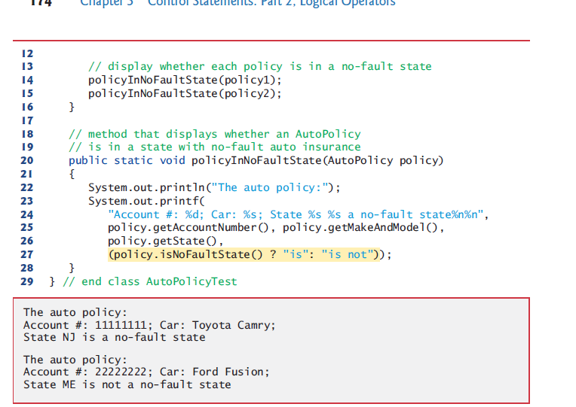

**-if else:** If statement allows you to perform actions when the condition is true. If else performs actions when the condition is true and perform another set of actions when the condition is false.

if (grade >= 60)

System.out.println(“Passed”);

else

System.out.println(“Failed”);

-When you are using if else statements make sure you test for all cases.

-Dont indent the else after if or if after else. Write nested if else statements in the same column like the example above.

-Normally we say indent the blocks that are inside other parts of program. But when it comes to if else, many programmers chose not to indent. Because it pushes the program to the right.

**-Dangling else problem:** Java compiler associates an else with the immediately preceding if unless told otherwise by the placement of brackets. First code below will be read like second code below by compiler. To get rid of the problem we need to write these statements like third code block.

if (x > 5)

if (y > 5)

System.out.println(“x and y are > 5”);

else

System.out.println(“x is <= 5”);

if (x > 5)

if (y > 5)

System.out.println(“x and y are > 5”);

else

System.out.println(“x is <= 5”);

if (x > 5) {

if (y > 5)

System.out.println(“x and y are > 5”);

}

else

System.out.println(“x is <= 5”);

**-Blocks:** The java compiler expects one statement to be in if’s body. So if you have more than one statement, compiler will think those statements comes after the if statement’s end. In order to get around this problem you need to use brackets like you do for dangling else problem. Statements contained in a pair of braces form a block.

A block of statements can be placed anywhere in a method that a single statement can be placed. It is possible to have an empty statement anywhere a single statement can be placed too.

-**Conditional operator(?): If else yapısı yerine kullanılabilir.**

**The statement:**

**statement1 ? statement2 : statement3;**

**means this:**

**if(statement1)**

**statement2**

**else**

**statement3**

**Conditional operator javadaki tek ternary operator(3 operanda sahip operator)’dür.**

-There are places where you can use conditional operator and cant use if else. One of them is i**t can be used to return a value.**

sonuc = not >= 50 ? "Basarili" : "Basarisiz";

printf( "%s\n", count % 2 ? "****" : "++++++++" );

-Use expressions of same type for second and third operands of conditional operator to avoid error caused by wrong variable types.

-Using conditional operator in printf and using strings as output values.

System.out.printf(

"Account #: %d; Car: %s; State %s %s a no-fault state%n%n",

policy.getAccountNumber(), policy.getMakeAndModel(),

policy.getState(),

(policy.isNoFaultState() ? "is": "is not"));

**-while:** A repetition statement allows you to specify a program should repeat an action while some condition remains true. Both while and for can be used for both sentinel and counter controlled statements. But while is generally used for sentinel controlled and for is generally used for counter controlled statements.

Counter controlled while statement:

int count = 1;

while (count <= 10) {

System.out.println("Count is: " + count);

count++;

}

-Not providing statements in the body of a while statement that eventually causes the condition to become false normally results in a logic error called an infinite loop.

-We stated that while could be used in most cases in place of for. One example where it cant is increment expression in the while follows a continue statement. In this case, the increment does *not* execute before the program evaluates the repetition-continuation condition, so the while does not execute in the same manner as the for.

count =

while (count < 11) {

System.out.println("Count is: " + count);

if (count == 5)

continue;

count++;

}

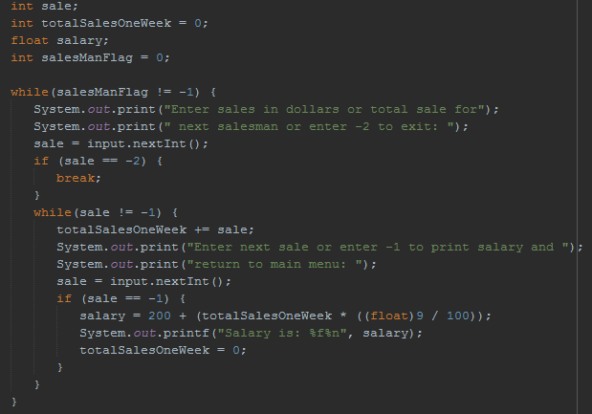

**-for:** Contains elements of counter controlled repetition in one line. The increment happens after body is executed. Then the continuation test is performed again.

-Pre increment or post increment Doesnt matter. Because for statement is equal to following while statement in java.

for (ForInit ; Expression ; ForUpdate)// Initialization, continuation test, inc.

forLoopBody(); // Body

-Initization is done only once at the beginning as you can see in the same example below.

{

ForInit; // Initialization

while (Expression) { // Continuation test

forLoopBody(); // Body

ForUpdate; // Increment

}

}

**-**Off-by-oneerror is the error when your loop executes one time more or less then you wanted or one more or less than where you wanted it to start from. To get over this problem generally use 1 and <=, >=. If you have to use 0 then use <, >.

-The first line including the keyword for and the paranthesis of for(with everything inside it) is called for statement header.

-Sentinel controlled for:

for(int sentinelValue = 0; sentinelValue >= 0; ) {

System.out.print("Enter a non negative value or enter a negative value to exit: ");

sentinelValue = input.nextInt();

System.out.println(sentinelValue);

}

-Omitting: All three expressions in a for header are optional.

If the loopContinuationCondition is omitted, Java assumes that the loop-continuation condition is always true, thus creating an infinite loop.

You might omit the initialization expression if the program initializes the control variable before the loop. You might omit the increment expression if the program calculates the increment with statements in the loop’s body or if no increment is needed.

-The increment expression in a for acts as if it were a standalone statement at the end of

the for’s body. Therefore, the expressions

counter = counter + 1

counter += 1

++counter

counter++

are equivalent increment expressions in a for statement. Many programmers prefer counter++

because it’s concise and because a for loop evaluates its increment expression *after*

its body executes, so the postfix increment form seems more natural. In this case, the variable

being incremented does not appear in a larger expression, so preincrementing and

postincrementing actually have the *same* effect.

-Arithmetic expressions in for statement’s header: The initialization, loop-continuation condition and increment portions of a for statement can contain arithmetic expressions. For example, assume that x = 2 and y = 10. If x and y are not modified in the body of the loop, the statement

for (int j = x; j <= 4 * x * y; j += y / x)

is equivalent to the statement

for (int j = 2; j <= 80; j += 5)

The increment of a for statement may also be *negative*, in which case it’s a decrement, and

the loop counts *downward*.

This is inefficient so you should avoid it.(Calculating the same expression every iteration.)

-Declaration and initialization at for header happens only at start.

-Using control variable’s value: Although the value of the control variable can be changed in the body of a for loop, avoid doing so, because this practice can lead to subtle errors. You can assign it to a temporary variable and use that but be careful.

-Using equality operators in continuation condition: Do not use equality operators (!= or ==) in a loop-continuation condition if the loop’s control

variable increments or decrements by more than 1. For example, consider the for statement

header for (int counter = 1; counter != 10; counter += 2). The loop-continuation test

counter != 10 never becomes false (resulting in an infinite loop) because counter increments

by 2 after each iteration.

-Using more than one initialization or increment: The initialization and increment expressions can be comma-separated lists that enable you to use multiple initialization expressions or multiple increment expressions. For example, although this is discouraged, you could merge the body of the for statement in lines 11–12 of Fig. 5.5 into the increment portion of the for header by using a comma as follows:

for (int number = 2; number <= 20; total += number, number += 2)

; // empty statement

-For readability limit the size of control-statement headers to a single line if possible.

-Executing a block multiple times: If you use a for block more than one time you gotta make sure you reset counter to initial value. To make sure this happens initialize the counter value so whenever that for block is executed counter is reseted. İt doesnt matter you also declare the counter in for or not.

-**do while:** The do…while statement tests the loop-continuation condition after executing the loop’s body; therefore, the body always executes at least once.

do {

System.out.println("Count is: " + count);

count++;

} while (count < 11);

-Braces in a do…while Repetition Statement: It isn’t necessary to use braces in the do…while repetition statement if there’s only one statement in the body. However, many programmers include the braces, to avoid confusion between the while and do…while statements.

**-switch:** The switch multiple-selection statement performs different actions based on the possible values of a constant integral expression of type byte, short, int or char. As of Java SE 7, the expression may also be a String.

-The switch statement consists of a block that contains a sequence of case labelsand an optional default case.

-The break statementcauses program control to proceed with the first statement after the switch.

-The switch statement does *not* provide a mechanism for testing *ranges* of values, so *every* value you need to test must be listed in a separate case label. Each case can have multiple statements. The switch statement differs from other control statements in that it does *not* require braces around multiple statements in a case.

-Case without a break statement: Without break statements, each time a match occurs in the switch, the statements for that case and subsequent cases execute until a break statement or the end of the switch is encountered. This is often referred to as “falling through” to the statements in subsequent cases. This happens because case is not a control statement. It is a label. It just says keep executing from here.

In the example below the same code executes for case 9 and 10. Because If case is 10 it executes code of 10 and breaks. If case is 9 then is doesnt execute anything for 9 but it falls to case 10 because there is no break and it executes code of case 10. Execution would fall to case 10 even if case 9 had statements inside but we dont have statements inside case 9 if we want the same statements to execute for multiple cases and also we dont put a break statement after case 9. Case 10 doesnt prevent falling through because it is not a flow control expression, it is a label.

case 9: // grade was between 90

case 10: // and 100, inclusive

++aCount;

break; // exits switch

Case’ler yan yanada yazilabilir.

switch (getState()) {

case "MA": case "NJ": case "NY": case "PA":

noFaultState = true;

break;

}

-The default case: If no match occurs between the controlling expression’s value and a case label, the default case executes. If no match occurs and the switch does not contain a default case, program control simply continues with the first statement after the switch.

Default case is usually put at the last. And even though it is last usually we we still use break statement to make default case look like others. You can use default case somewhere other than bottom too.

Using default makes your code robust aganist exceptions.

Default case works no matter what so placing it last is a nice way to prevent it from being executed accidentally.

-Expressions in cases of switch: When using the switch statement, remember that each case must contain a constant integral expression—that is, any combination of integer constants that evaluates to a constant integer value (e.g., –7, 0 or 221)—or a String. An integer constant is simply an integer value. In addition, you can use character constants—specific characters in single quotes, such as 'A', '7' or '$'—which represent the integer values of characters and enum constants.

The expression in each case can also be a constant variable—a variable containing a

value which does not change for the entire program. Such a variable is declared with keyword

final. Enum type constants can also be used in case labels.

We can also use constant String expression for switch controlling expression which consist of string literals and constant string variables.

Also you can write cases horizontal to save space

case "MA": case "NJ": case "NY": case "PA":

In Chapter 10, Object-Oriented Programming: Polymorphism and Interfaces, we

present a more elegant way to implement switch logic—we use a technique called polymorphism

to create programs that are often clearer, easier to maintain and easier to extend

than programs using switch logic.

**Enhanced For:** See array section.

**-Unconditional Control Statements:** Java provides statements return, break and continue to alter the flow of control. return can be used anywhere in the program(go to can be used anywhere in the program too but there is no go to in Java but there is go to in C and C#). break and continue can only be used in loops. break can also be used in switch.

-break

-continue

-return

-Note:go to(goto is not a keyword in java. It doesnt work ın java but it is a reserved word.) Also go to is not an unconditional control statement. Break, continue and return all jump to known positions and they dont void structured programming logic. They dont get out of frame stack. Go to gets out of frame stack, voiding structured programming.

**-break:** The break statement, when executed in a while, for, enhanced for, do…while or switch, causes immediate exit from that statement. Normally break is used to get out of a loop but it is used in switch too.

for (count = 1; count <= 10; count++) { // loop 10 times

if (count == 5)

break;

System.out.printf("%d ", count);

}

-break and continue are not part of structured programming and some programmers avoid using them by using other ways(for break statement one way of replacing is adding extra control expression) to exit their repetition or continue with the next iteration to their repetition.

if (count == 5)

break; // terminates loop if count is 5

for (count = 1; count <= 10 && count != 5; count++)

**-Label break:** Used to exit out of more than one loop. The flow of control is not transfered to label. Label just shows which repetition statement we broke from. We can only put labels to repetition statements we are in right now. Which means writing break outer1 or outer2 works but break outer3 wont compile.

outer1;

for…

outer2;

for…

{

…

break outer;

}

outer3:

for…

**-continue:** The continue statement, when executed in a while, for, enhanced for, or do…while, skips the remaining statements in the loop body and proceeds with the next iteration of the loop.

In while and do…while statements, the program evaluates the loop-continuation test immediately

after the continue statement executes.

In a for statement, the increment expression executes, then the program evaluates the loop-continuation test.

for (int count = 1; count <= 10; count++) { // loop 10 times

if (count == 5)

continue;

System.out.printf("%d ", count);

}

-We stated that while could be used in most cases in place of for. This is *not* true when the increment expression in the while follows a continue statement. In this case, the increment does *not* execute before the program evaluates the repetition-continuation condition, so the while does not execute in the same manner as the for.

while (count < 11) {

System.out.println("Count is: " + count);

if (count == 5)

continue;

count++;

}

-To avoid using continue you can use if else statements to avoid executing code for a condition.

for (int count = 1; count <= 10; count++) {

if (count == 5)

continue;

System.out.printf("%d ", count);

}

for (int count = 1; count <= 10; count++) {

if (count != 5)

System.out.printf("%d ", count);

}

**-Label continue:** Doesnt reiterate current loop. Reiterates the outer loop.

outer1;

for…

outer2;

for…

{

…

continue outer;

}

outer3:

for…

**-return:** Return 0 is generally used for successful return indication while 1 is unsuccessful return indication.

* **Methods:** You write Java programs by combining new methods and classes with predefined ones available in the Java Application Programming Interface (also referred to as the Java API or Java class library) and in various other class libraries.

The Java API provides a rich collection of predefined classes that contain methods for performing common mathematical calculations, string manipulations, character manipulations, input/output operations, database operations, networking operations, file processing, error checking and more.

Don’t reinvent the wheel. When possible, reuse Java API classes and methods. This reduces

program development time and avoids introducing programming errors.

**-Divide and Conquer with Classes** **and Methods:** Classes and methods help you modularize a program by separating its tasks into self-contained units(modules). Methods are declared within classes. Classes are typically grouped into packages so they can be imported and used.

The statements in the method bodies are written only once, are hidden from other methods and can be reused from several locations in a program.

One motivation for modularizing a program into classes and methods is the *divide-and-*

*conquer* approach, which makes program development more manageable by constructing

programs from small, simple pieces. Another is software reusability—using

existing classes and methods as building blocks to create new programs.

A third motivation is to *avoid repeating code*. Dividing a program into meaningful classes and methods makes the program easier to debug and maintain.

-To promote software reusability, every method should be limited to performing a single,

well-defined task, and the name of the method should express that task effectively.

-A method is invoked by a method call, and when the called method completes its task, it returns control and possibly a result to the caller.

-The boss method(the method that calls other methods) does not know how the worker method performs its designated tasks. The worker may also call other worker methods, unbeknown to the boss. This “hiding” of implementation details promotes good software engineering.

-You should control return values of methods and act accordingly if the method was succesful or not.

-Java is pass by value (as opposed to pass by reference). We dont pass pointers. If you need to pass a value or an adress(reference) you copy the value or the adress and pass that. You dont pass the actualy original pointer(pass by reference).

**-Static methods and variables:** Sometimes a method performs a task that does not depend on an object. Such a method applies to the class in which it’s declared as a whole and is known as a static method or a class method. Static methods and variables are generally used for common fields and tasks that doesnt need an object.

To declare a method as static, place the keyword static before the return type in the method’s declaration. For any class imported into your program, you can call the class’s static methods by specifying the name of the class in which the method is declared, followed by a dot (.) and the method name, as in

ClassName.methodName(arguments);

Non-static methods are typically called instance methods.

There are variables for which each object of a class does *not* need its own separate copy. Such variables are declared static and are also known as class variables. When objects of a class containing static variables are created, all the objects of that class share *one* copy of those variables. Together a class’s static variables and instance variables are known as its fields.

For example E and PI variables in Math class are declared with the modifiers public, final and static.

Static methods in a class can call each other without a need for an object. We can even call the main method but we dont.

**-Static object(Static Class):** Static object in java is actually a class, all of whose members are declared static. It can be used in an application to provide global access to methods or variables.

More information on this. Why cant we just have a non static object that has public static fields?

**-Final:** Any field declared with keyword final is *constant*—its value cannot change after the field is initialized. (pg 247)

You can either assign a value to final variables initially or in constructor. Constant variables are always named all caps.

private static final int SNAKE_EYES = 2;

-Final fields must be initialized in its declaration or in every constructor or a compilation error occurs.

-Final locals, parameters. Same as fields

-If you use declare an object final that means you cant reassign something else to that object. (You cant assign some other address to that pointer that is holding address of this object.) But you can use methods and variables and change variables of tis object.

final A ob = new A(); // Works

ob.setI(6)

final A ob = new A(); // Doesn’t work

ob = new A();

**-**Final classes cannot be subclassed.

-Final is used with a Java method to mark that the method can't be overridden (for object scope) or hidden (for static). This allows the original developer to create functionality that cannot be changed by subclasses.

**Why is method main declared static:** When you execute the Java Virtual Machine (JVM) with the java command, the JVM attempts to invoke the main method of the class you specify—at this point no objects of the class have been created. Declaring main as static allows the JVM to invoke main without creating an instance of the class. When you execute your application, you specify its

class name as an argument to the java command, as in

java *ClassName argument1 argument2* …

The JVM loads the class specified by *ClassName* and uses that class name to invoke method

main. In the preceding command, *ClassName* is a command-line argumentto the JVM

that tells it which class to execute. Following the *ClassName*, you can also specify a list of

Strings (separated by spaces) as command-line arguments that the JVM will pass to your

application. Such arguments might be used to specify options (e.g., a filename) to run the

application. Your application can access those command-line arguments and use them to customize the application.

-There must be one argument in the method call for each parameter in the method declaration. Also, each argument must be *consistent* with the type of the corresponding parameter.

-When program control returns to the point in the program where maximum was called,

maximum’s parameters x, y and z no longer exist in memory.

**-**Methods can return at most one value, but the returned value could be a reference to an

object that contains many value.

**-**Variables should be declared as fields only if they’re required for use in more than one method

of the class or if the program should save their values between calls to the class’s methods.

-Declaring method parameters of the same type as float x, y instead of float x, float

y is a syntax error—a type is required for each parameter in the parameter list.

-You can use methods to return values to other methods. This way you can implement software reuse.

return Math.max(x, Math.max(y, z)); // instead of writing our own maximum method body we executed this statement in our methods body

**-Declaring and using methods:** There are three ways to call a method:

**1-** Using a method name by itself to call another method of the *same* class—such as

maximum(number1, number2, number3) pages 247-248.

**2-** Using a reference to an object(which is a variable), followed by a dot (.) and

the method name to call a non-static method of the referenced object like

myAccount.getName pg 116.

**3-** Using the class name and a dot (.) to call a static method of a class—such as

Math.sqrt(900.0) in page 245.

**-Returning a method:**

**1-** Reaching right brace(closing brace).

**2-** return; You can use return; statement in no return value methods too to get out of the method.

**3-** return value;

A static method can call other static methods of the same class directly (i.e., using

the method name by itself) and can manipulate static variables in the same class directly.

To access the class’s instance variables and instance methods, a static method must use

a reference to an object of the class. Instance methods can access all fields (static variables

and instance variables) and methods of the class.

Recall that static methods relate to a class as a whole, whereas instance methods are

associated with a specific instance (object) of the class and may manipulate the instance

variables of that object.

**-Accessing to Methods and Fields:**

Instancemeans non static(belongs to instance(object)).

Access modifiers are important when determining their scope/accessability.

In order to use instance variables/methods you need to create instances first.

Use “this” for instance variable/methods, use “ClassName.___” For static variables/methods.

**-Same Class:**

**-Static variable:** We can access a static variable from instance and static methods directly if there is no shadowing local variable. If there is, access it with ClassName.variableName.

**-Static method:** We can access a static method from instance and static methods directly.

**-Instance variable:** Instance variables and generally private. So they are generally used in instance methods of its own class. We can access instance variables from instance methods directly if there is no shadowing. If there is, access it with “this”. We can’t access instance variables directly from static methods. From static methods, after making sure that object is defined in your static method(either declare in static method or send object as argument) use objectName.variableName;

Objects of same class can access each others private instance variables but its not recommended)

**-Instance method:** Instancemethods and generally public. We can access instance methods directly from instance methods We cant access them directly from static methods. From static methods, after making sure that object is defined in your static method(either declare in static method or send object as argument) use objectName.methodName;

**-Another Class(imported):** Different objects have to have different names so you dont have to worry about object or method name collision.

**-Static variable:** If we are in its scope (determined by its access modifier), we can access it from instance and static methods with ClassName.variableName.

**-Static method:** If we are in its scope (determined by its access modifier), we can access it from instance and static methods with ClassName.methodName().

**-Instance variable:** They are generally private. So they are not accessed from other classes. If its not private and we are in its scope (determined by its access modifier), after making sure that object is defined in your static method(either declare in static method or send object as argument) access it from instance and static methods using objectName.variableName;

**-Instance method:** If we are in its scope (determined by its access modifier), after making sure that object is defined in your static method(either declare in static method or send object as argument) access it with objectName.methodName().

**-Method Call Stack and Stack Frames:** When a program calls a method, the called method must know how to return to its caller, so the return address of the calling method is pushed onto the method-call stack. If a series of method calls occurs, the successive return addresses are pushed onto the stack in last-in, first-out(first-in, last out) order so that each method can return to its caller.

The method-call stack also contains the memory for the local variables (including the

method parameters) used in each invocation of a method during a program’s execution.

This data, stored as a portion of the method-call stack, is known as the stack frame (or

activation record) of the method call. When a method call is made, the stack frame for

that method call is pushed onto the method-call stack. When the method returns to its

caller, the stack frame for this method call is popped off the stack and those local variables

are no longer known to the program. If a local variable holding a reference to an object is

the only variable in the program with a reference to that object, then, when the stack frame

containing that local variable is popped off the stack, the object can no longer be accessed

by the program and will eventually be deleted from memory by the JVM during garbage

collection.

Of course, a computer’s memory is finite, so only a certain amount can be used to

store stack frames on the method-call stack. If more method calls occur than can have their

stack frames stored, an error known as a stack overflow occurs.

**-Argument Promotion and Casting:** Converting an argument’s value, if possible, to the type that the method expects to receive in its corresponding parameter.

Conversions may lead to compilation errors if Java’s promotion rules are not satisfied. These rules specify which conversions are allowed—that is, which ones can be performed without losing data.

The promotion rules apply to expressions containing values of two or more primitive

types and to primitive-type values passed as arguments to methods. Each value is promoted

to the “highest” type in the expression. Actually, the expression uses a temporary

copy of each value—the types of the original values remain unchanged.

In cases where information may be lost due to conversion, the Java compiler requires

you to use a cast operator to explicitly force the conversion to occur.

square((int) doubleValue)

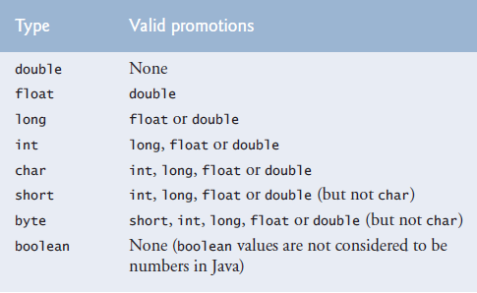

-Long can be assigned to float because floating point variables are held in a different way then integers. Which allow 32 bit float to hold value of 64 bit long.

**-Secure Random-Number Generation**(import java.security.SecureRandom;):The element of chance can be introduced in a program via an object of class Secure-Random (package java.security). Such objects can produce random boolean, byte, float, double, int, long and Gaussian values.

More information about gaussian values: <http://www.javamex.com/tutorials/random_numbers/gaussian_distribution_2.shtml>

Generating random char: <https://stackoverflow.com/questions/2626835/is-there-functionality-to-generate-a-random-character-in-java>

Recent editions of this book used Java’s Random class to obtain “random” values. This class

produced deterministic values that could be predicted by malicious programmers. Secure-

Random objects produce nondeterministic random numbers that cannot be predicted. Nondeterministic algorithms can exhibit different behaviour even for same input.

import java.security.SecureRandom;

SecureRandom randomNumbers = new SecureRandom();

int randomValue = randomNumbers.nextInt();

If it truly produces values *at random*, then every value in the range should have an *equal chance* (or probability) of being chosen each time nextInt is called.

SecureRandom provides another version of method nextInt that receives an int argument and returns a value from 0 up to, but not including, the argument’s value.

int face = randomNumbers.nextInt(6);

The argument 6—called the scaling factor—represents the number of unique values that nextInt should produce (in this case six—0, 1, 2, 3, 4 and 5). This manipulation is called scaling the range of values produced by SecureRandom method nextInt.

A six-sided die has the numbers 1–6 on its faces, not 0–5. So we shiftthe range of numbers produced by adding a shifting value—in this case 1—to our previous result, as in

int face = 1 + randomNumbers.nextInt(6);

int number = *shiftingValue* + randomNumbers.nextInt(*scalingFactor*);

where shiftingValue specifies the first number in the desired range of consecutive integers and scalingFactor specifies how many numbers are in the range.

It’s also possible to choose integers at random from sets of values other than ranges of

consecutive integers. For example, to obtain a random value from the sequence 2, 5, 8, 11

and 14, you could use the statement

int number = 2 + 3 * randomNumbers.nextInt(5);

int number = *shiftingValue* + *differenceBetweenValues* * randomNumbers.nextInt(*scalingFactor*);

where *shiftingValue* specifies the first number in the desired range of values, *difference-BetweenValues* represents the *constant difference* between consecutive numbers in the sequence and *scalingFactor* specifies how many numbers are in the range.

1, 2, 4, 8, 16, 32 -> n = Math.pow(2, randomNumbers.nextInt(6));

**-A Note About Performance:**Using SecureRandom instead of Random to achieve higher levels of security incurs a significant performance penalty. For “casual” applications, you might want to use class Random from package java.util—simply replace SecureRandom with Random.

**-Enum:** Enum declares a set of identifiers which are constants. These constants are called enum constants. So we use constant identifier conventions while naming them. But these are not variables. They are the values.

Defining new enum types cant be done in methods. Must be done in field.

private enum Status { CONTINUE, WON, LOST };

Status gameStatus;

You cant assign strings to an enum type variable. You have to assign one of its values to it.

gameStatus = “Won”; // Wrong

gameStatus = Status.WON; // Correct

while (gameStatus == Status.CONTINUE)

**-Why do we use enum and final primitive variables** Using enum constants instead of literals like 0, 1, 2 make the program easier to read and maintain. But using an enum becomes unpractical if you need to compare the enum value with something else or use it in a calculation or an expression etc. . You can do it with switch statements but it defeats the purpose of using enums which is making the program more readable. So in these places use final variables. Named constants can be declared using both enum types and final variables (Named constants is a general name for these two). But enum type you define in field is known to all instances of class and class itself so enums are implicitly static finals.

**-Scope:** Look at the variable types section.

**-Method Overloading:** Methods of the same name can be declared in the same class, as long as they have different sets of parameters (determined by the number, types and order of the parameters)—this is called method overloading. When an overloaded method is called, the compiler selects the appropriate method by examining the number, types and order of the arguments in the call.

obj.sum(10);

obj.sum(20, 20);

**-Distinguishing Between Overloaded Methods:** The compiler distinguishes overloaded methods by their signatures—a combination of the method’s name and the number, types and order of its parameters, but not its return type.

Internally, the compiler uses longer method names that include the original method name, the types of each parameter and the exact order of the parameters to determine whether the methods in a class are unique in that class.

**-Return Types of Overloaded Method:** Method calls cannot be distinguished only by return type. Overloaded methods can have different return types if the methods have different parameter lists. Also, overloaded methods need not have the same number of parameters.

Return types of methods alone doesnt tell us which method we should use because we cant know what the return type is before executing the method with the input.

**-Overloading main method:** You can overload main method in Java. But the program doesn't execute the overloaded main method when you run your program, you have to call the overloaded main method from the actual main method.

**-varargs in method overloading:** You can’t use varargs in overloading.

**-Variable amount of parameters(varargs):** You can only have one varArg per method. Must be at the end of parameter list.

public static void test(String... stringArray)

{

int x = stringArray.length;

System.out.println(stringArray[1]);

String a = stringArray[1];

}

**-Leaving method or program:** We use return to leave the method we are in and return to the stack below us (stack). If we are in the last method in stack, return exits the program (Generally main method). We use System.exit(int) to leave the program no matter where we are. 0 for succesful exit, 1 for unsuccesful exit.

* **Arrays and ArrayLists888888:** Array objects are data structures consisting of related data items of the same type. Arrays remain same length once they are created.

-Variables in an array are called elements or components.

**-**Arrays are objects in java so they are considered reference types (pointer). An array is actually a reference in stack to an array object in heap memory.

-Elements can be primitive or reference types (including arrays).

-Every element of a primitive-type array contains a variable of the array’s declared type. Every element of a reference-type array is a reference to an object of the array’s declared type.

**-Declaring and initializing arrays:** To create an array object, you specify the type of the array elements and the number of elements as part of an array creation expression that uses keyword new. Such an expression returns a reference that can be stored in an array variable.

-Their size must be declared before using. Every array object knows its own length and stores it in a length instance variable. Even though the length instance variable of an array is public, it cannot be changed because it’s a final variable. There are two ways of declaring its size as shown below.

-Elements of arrays get default values of their data type when the array is created. (Both locals and fields.)

-int[] array;

array = new int[10]; // Declaration of array reference and creation of array done discretely.

-int[] array = new int[10]; // Array creation expression. Declaration of array reference and creation of array done together. Declares array (a reference capable of referring to an array of int elements) then initializes the variable with a reference to an array object containing 10 int elements.

-int[] array;

array = new int[]{1, 10, -7};

-int[] array = { 1, 10, -7 }; // Array initializer(complete statement) and the intializer list. Length of the array is determined by the number of elements in the initializer list. Compiler actually takes a look at your array initializer and sets up the appropriate array declaration and initialization using new behind the scenes.

-Creating an array in an argument list and assigning it to the respective parameter.

import java.util.Arrays;

public class Foo {

public void method(String[] myStrArray) {

System.out.println(Arrays.toString((myStrArray)));

}

public static void main(String[] args) {

Foo foo = new Foo();

foo.method(new String[]{"hello", "goodbye"}); // **array created inline**

}

}

-Multiple arrays can be created in a single declaration. But its not recommended and it can cause subtle errors.

-To refer to a particular element in an array, we specify the name of the reference to the array and the position number of the element in the array (the element’s index or subscript.) in square brackets ( [] ). This is called an array access expression. First index is 0. (Zero based counting.) Indexes can be any non negative integer value other then long. Expressions can be used as indexes.

myArray[0] = 10;

myArray[a + b] = 5;

-When only one variable is declared in each declaration, the square brackets can be placed either after the type or after the array variable name. But placing the square brackets after the type is preferred. Same for method parameters.

**-ArrayIndexOutOfBounds Exception:** An exception indicates a problem that occurs while a program executes. Exception handling helps you create fault-tolerant programs that can resolve (or handle) exceptions. When the JVM or a method detects a problem, such as an invalid array index or an invalid method argument, it throws an exception—that is, an exception occurs.

-The try block contains the code that might throw an exception, and the catch block contains the code that handles the exception if one occurs. You can have many catch blocks to handle different types of exceptions that might be thrown in the corresponding try block.

-When an exception is thrown the try block is terminated and catch block starts executing. If you declared any local variables in the try block, they are now out of scope. The catch block declares an exception parameter (e) of type (IndexOutOfRangeException). The catch block can handle exceptions of the specified type. Inside the catch block, you can use the parameter’s identifier to interact with a caught exception object.

**-How to handle it:** When writing code to access an array element, ensure that the array index remains greater than or equal to 0 and less than the length of the array. This would prevent ArrayIndex-

OutOfBoundsExceptions if your program is correct.

**-Implicit toString and get/set methods:** When the code in catch block

catch (ArrayIndexOutOfBoundsException e) {

System.out.println(e); // invokes toString method

executes, the toString method of exception object is implicitly called to get the error message that’s stored in the exception object and display it.

-When you use a non string variable where a string is expected, its class’s (static methods belong both to class and its methods) toString method executes implicity.

-For this effect to occur, toString must be declared with the header below

public String toString()

-There can only be one toString method in a class but there can be multiple get methods. So toString method is implicitly called when we use the object in a place where a string is expected. Get method is called implicitly when we ask for it in xhtml. When we call beanName.time in xhtml we implicitly call public getTime method.

**-NullPointerException:** Occurs when you try to call a method on a null reference,In industrial-strength code, ensuring that references are not null before you use them to call methods prevents NullPointerExceptions.

**-Enhanced For:** The enhanced for statement iterates through the elements of an array without using a counter, thus avoiding the possibility of “stepping outside” the array or other errors due to the initial value of counter , loop continuation test and increment expression. But if you need to use counter in your program, you need to use the counter controlled for statement.

-The type of the parameter must be consistent with the type of the elements in the array.

-The statement’s header can be read as “for each iteration, assign the next element of array to int variable number, then execute the following statement.”

-The enhanced for statement can be used only to obtain array elements—it cannot be used to modify elements. Because iteration variable is just a copy of the array element.

<https://stackoverflow.com/questions/15844443/why-java-foreach-doesnt-change-element-value>

**-**Using with one dimensional arrays:

for (int counter = 0; counter < array.length; counter++)

total += array[counter];

for (int number : arrays)

total += number;

-When naming the “counter” in enhanced for, dont use names that would describe counter. Use names that would describe array[counter] such as value instead of counter.

-Using with multidimensional arrays: As long as you have more dimensions below the current array, the left value as an array. Thats why we are able to use that left value(arrayRow) in the place of where an array is supposed to go in the statement below. But the left value below(arrayColumn) is not an array. You can see which variable is what data type and how many dimensions it has by looking at its data type left of it. arrayRow is an int[] while arrayColumn is an int.

for (int[] arrayRow : array) // Does the same thing as normal fors below.

for (int arrayColumn : arrayRow)

System.out.println(arrayColumn);

**-Passing arrays to methods:** When an argument to a method is an entire array or an individual array element of a reference type, the called method receives a copy of the reference. However, when an argument to a method is an individual array element of a primitive type, the called method receives a copy of the element’s value. Such primitive values are called scalars or scalar quantities.

<https://stackoverflow.com/questions/6623130/scalar-vs-primitive-data-type-are-they-the-same-thing>

You can read, modify elements of an array(or array element of reference type) if you pass array’s reference(or array element of reference type) to the method but you cant modify elements of an array if you pass just primitive values of elements not reference of the array or reference type array element.

int[] array = new int[10]; // Creating the array/

modifyArray(array); // Copying the reference of the array to the parameter in method.

calculateSqrt(array[3]); // Copying one element’s value to the parameter in method. (If array elements are primitive type then we pass value, if array elements are reference type we pass reference of the element)

public static void modifyArray(int[] array)

{

…

}

**-Pass by Reference, Pass by Value:** There are two ways of passing arguments to methods.

-**In other languages:**

-When an argument is passed by value, a copy of the argument’s value is passed to the called method. The called method works exclusively with the copy. (Which is in stack) Changes to the called method’s copy do not affect the original variable’s value in the caller.

-When an argument is passed by reference, the called method can access the argument’s

value in the caller directly and modify that data, if necessary. Pass-by-reference improves performance by eliminating the need to copy possibly large amounts of data.

-**In Java:**

Unlike some other languages, Java does not allow you to choose pass-by-value or pass by-reference—all arguments are passed by value. A method call can pass two types of values to a method—copies of primitive values (e.g., values of int and double) and copies of references to objects.

Objects themselves cannot be passed to methods. When a method modifies a primitive-type parameter, changes to the parameter have no effect on the original argument value in the calling method.

If you modify a reference-type parameter so that it refers to another object, only the parameter refers to the new object—the reference stored in the caller’s variable still refers to the original object.

Although an object’s reference is passed by value, a method can still interact with the

referenced object by calling its public methods using the copy of the object’s reference. Since the reference stored in the parameter is a copy of the reference that was passed as an argument, the parameter in the called method and the argument in the calling method refer to the *same* object in memory.

Passing references to arrays, instead of the array objects themselves, makes sense for performance reasons. Because everything in Java is passed by value, if array objects were passed,

a copy of each element would be passed. For large arrays, this would waste time and consume

considerable storage for the copies of the elements.

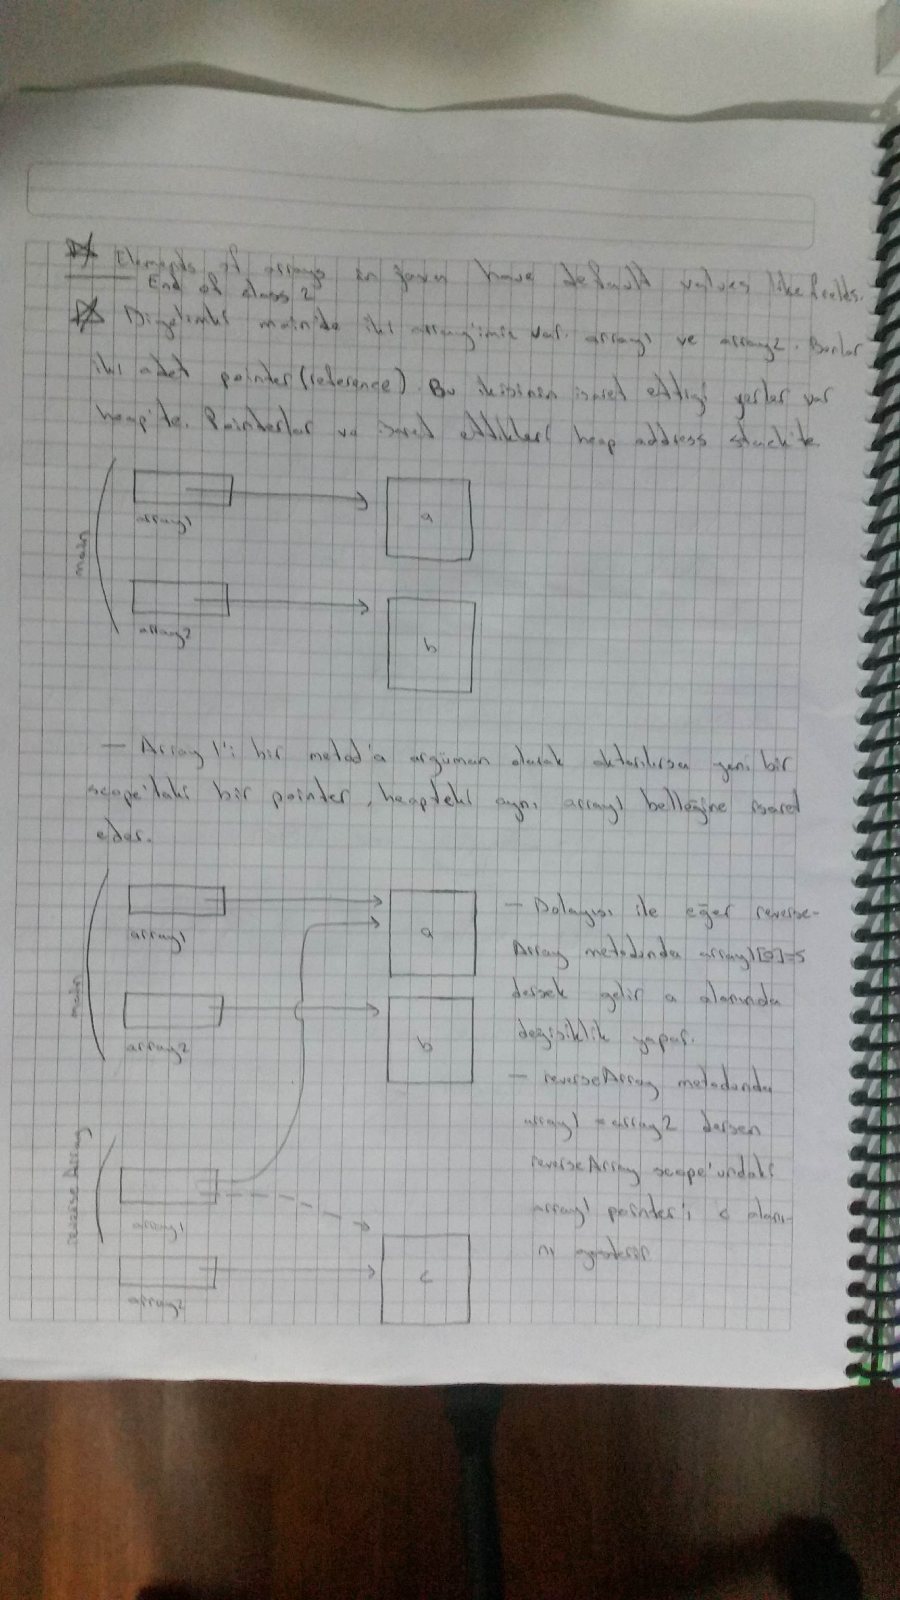

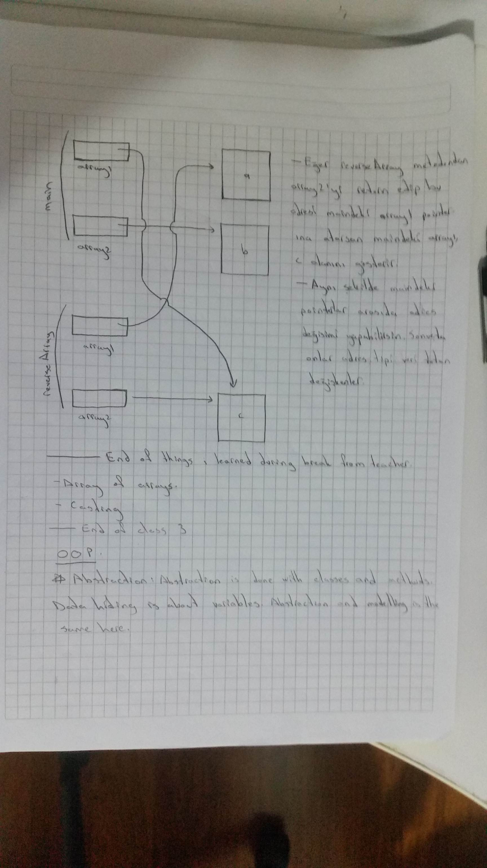

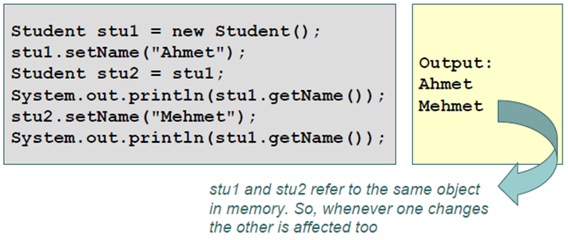

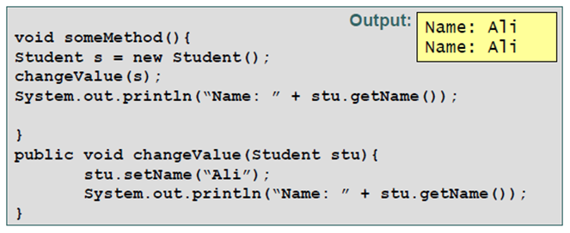

**-Multi-Dimensional arrays:** Java does not support multidimensional arrays directly, but it allows you to specify one-dimensional arrays whose elements are also one-dimensional arrays(arrays of arrays, arrays of one dimensional arrays), thus achieving the same effect. You can nest this to get as much dimensions as you want. This also allows variable length multidimensional arrays.

You have to specify the length of the first dimension. This is basically the same thing as an “array must have a length”. You havent created the lower level arrays yet. So you can specify their length later when you create them. You can acces length of the array by using arrayName.length.

An array with m rows and n columns is called an m-by-n array.

int[][] array = new int[2][3]; // Array creation expression.

int[][] array = {{ 1, 2, 3 }, { 4, 5, 6 }}; // Nested array initializer. Compiler counts number of nested array initializers to determine the number of rows in array named “array”. The compiler counts the initializer values in the nested array initializer for a row to determine the number of columns in that row. Every row can have different length.

array1[0][0] = 10; // Example to value assignment.

**-Multi-Dimensional arrays with different lengths:** All arrays have to be the same data type.

int[][] array = {{ 1, 2 }, { 3, 4, 5 }}; // First way.

int[][] array = new int[5][]; // Second way. Length of the array is 5. Holds 5 reference for 5 one dimensional arrays. Array creation expression can use literal values or variables to specify array dimensions, because new creates arrays at execution time—not at compile time.

array[0] = new int[2]; // When we use this second way we have to use new.

array[1] = new int[5];

array[2] = new int[3];

array[3] = new int[2];

array[4] = new int[3];

**-Traversing multi dimensional arrays:**

for (int row= 0; row < array.length; row ++) // Traversing way 1

{

for (int column = 0; column < array[row].length; column++)

{

System.out.printf("%d ", array[row][column]);

}

System.out.println();

}

for (int[] arrayRow : array) // Traversing way 2

{

for (int arrayColumn : arrayRow)

{

System.out.printf("%d ", arrayColumn);

}

System.out.println();

}

**-Traversing a certain row(or lower dimension) of a multi dimensional array:**

for (int column = 0; column < array[1].length; column++) // Traversing way 1

{

System.out.printf("%d ", array[1][column]);

}

for (int column : array[1]) // Traversing way 2

{

System.out.printf("%d ", column);

}

**-Variable Length Argument Lists:** With variable-length argument lists, you can create methods that receive an unspecified number of arguments. A type followed by an ellipsis (...) in a method’s parameter list indicates that the method receives a variable number of arguments of that particular type. This use of the ellipsis can occur only once in a parameter list, and the ellipsis, together

with its type and the parameter name, must be placed at the end of the parameter list.

The method body access variable number of parameters as an array of that data type.

**-**varargs has to be the last parameter in parameter list and has to be the only varargs so the compiler knows which argument is for which parameter. Otherwise the compiler wouldnt know if an argument belongs to varargs or the parameter after varargs.

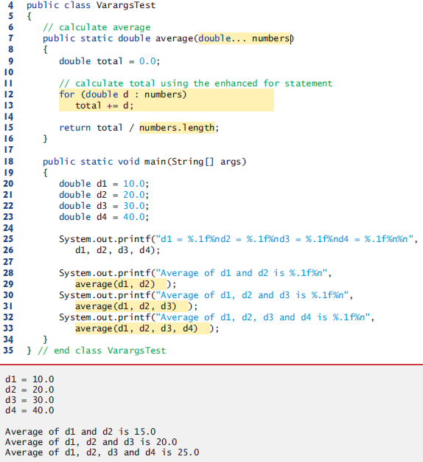

**-Command-Line Arguments:** It’s possible to pass arguments from the command line to an application via method main’s String[] parameter, which receives an array of Strings. By convention, this parameter is named args. When an application is executed using the java command, Java passes the command-line arguments that appear after the class name in the java command to the application’s main method as Strings in the array args. When we execute an application we call class’s main method with arguments(if no arguments is entered then the string is empty.)

-Common uses of command line arguments include passing options and filenames to applications.

-Command-line arguments are separated by white space, not commas. So the text you enter is not a single string you get as a string parameter. You get an array of strings seperated by spaces. If the data you want to enter includes spaces than use quotes around your string.

java initArray 50 0 40 // This is how we executed the program from command line. So we have an args string array with 3 strings.

int exam1 = Integer.parseInt(args[0]);

int exam2 = Integer.parseInt(args[1]);

int exam3 = Integer.parseInt(args[2]);

**-Array methods:** For the list of methods and more information on them use IDE autocomplete feature after writing “arrayName.” or API Spec.

-arrayName.length;

-arrayName.equals(arrayName2); // Only checks if pointers are pointing to the same array object. Arrays that are not same can be equal too. Use Arrays.equals method instead.

public boolean equals(Object obj) {

return (this == obj);

}

**-Class Arrays**(import java.util.Arrays;):For the list of methods and more information on them use IDE autocomplete feature after writing “Arrays.” or API Spec..

-boolean = Arrays.equals(array1, array2); // Checks if pointers are pointing to the same array object. If at least of them is pointing to null. If their length is same. If their elements are same.

public static boolean equals(int[] a, int[] a2) {

if (a==a2)

return true;

if (a==null || a2==null)

return false;

int length = a.length;

if (a2.length != length)

return false;

for (int i=0; i<length; i++)

if (a[i] != a2[i])

return false;

return true;

}

-Arrays.sort(array);

-Arrays.fill(array, 7);

-System.arrayCopy(array, 0, arrayCopy, 0, length); // The first zero is the starting index of the first array which we copy and the second zero is the index where we start copying to.

**-**int location =Arrays.binarySearch(array, 5); // If it can’t find the 5 character, it returns a negative value(More information in algorithms section). We dont have to search only for characters. Some search algorithms like binary search require sorted arrays.

int location =Arrays.binarySearch(array, 8763);

<http://docs.oracle.com/javase/7/docs/api/java/util/Arrays.html>

**-Introduction to Collections and Class ArrayList**(import java.util.ArrayList;):The Java API provides several predefined data structures, called collections, used to store groups of related objects in memory. These classes provide efficient methods that organize, store and retrieve your data without requiring knowledge of how the data is being stored. This reduces application-development time.

-It can dynamically change its size to accommodate more elements.

-ArrayList<String> list;

Declares list as an ArrayList collection that can store only Strings.

-Classes with this kind of placeholder that can be used with any type are called generic classes. Only nonprimitive types can be used to declare variables and create objects of generic classes. However, Java provides a mechanism—known as boxing—that allows primitive values to be wrapped as objects for use with generic classes.

-ArrayList<Integer> integers;

Declares integers as an ArrayList that can store only Integers. When you place an int value into an ArrayList<Integer>, the int value is boxed (wrapped) as an Integer object, and when you get an Integer object from an ArrayList<Integer>, then assign the object to an int variable, the int value inside the object is unboxed (unwrapped).

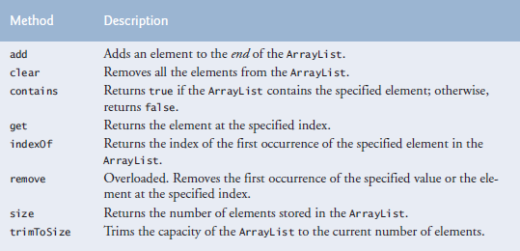

Use IDE autocomplete feature or API Spec. to see other methods.

-Default initial capacity of 10 elements. The capacity indicates how many items the ArrayList can hold without growing. ArrayList is implemented using a conventional array behind the scenes. When the ArrayList grows, it must create a larger internal array and copy each element to the new array. This is a time-consuming operation. It would be inefficient for the ArrayList to grow each time an element is added. Instead, it grows only when an element is added and the number of elements is equal to the capacity—i.e., there’s no space for the new element.

-Inserting an element is usually slower than adding an element to the end of the ArrayList.

-Contains metho can be inefficient too because it compares its agrument to each element of the ArrayList in order.

ArrayList<String> items = new ArrayList<String>();

items.add("red"); // append an item to the list

items.add(0, "yellow"); // insert "yellow" at index 0

items.remove("yellow"); // remove the first "yellow"

items.remove(1); // remove item at index 1

// check if a value is in the List

System.out.printf("\"red\" is %sin the list%n", items.contains("red") ? "": "not ");

System.out.printf("Size: %s%n", items.size()); // display number of elements in the List

for (int i = 0; i < items.size(); i++)

System.out.printf(" %s", items.get(i));

for (String item : items)

System.out.printf(" %s", item);

***Java SE 7—Diamond (<>) Notation for Creating an Object of a Generic Class***

ArrayList<String> items = new ArrayList<String>();

Notice that ArrayList<String> appears in the variable declaration and in the class instance

creation expression. Java SE 7 introduced the diamond (<>) notation to simplify statements

like this. Using <> in a class instance creation expression for an object of a generic class tells

the compiler to determine what belongs in the angle brackets. In Java SE 7 and higher, the

preceding statement can be written as:

ArrayList<String> items = new ArrayList<>();

When the compiler encounters the diamond (<>) in the class instance creation expression,

it uses the declaration of variable items to determine the ArrayList’s element type

(String)—this is known as inferring the element type.

* **Classes and Objects: A Deeper Look**

-Java conserves storage by maintaining only one copy of each instance method per class(static methods already have one copy)—this method is invoked by every object of the class. Each object, on the other hand, has its own copy of the class’s instance variables. Each method of the class implicitly uses this to determine the specific object of the class to manipulate. When class loader loads this class to ram, there is only one of each instance method loaded in ram. You should use synchronized and other things you learned in concurrency chapter to prevent multithreading mistakes. (tag: save space)

-Classes dont take any space. Objects do.

-Constructor calling ( this(args) or super(args) )must be the first statement in constructors or not exist at all.

**-Overloading constructors:**

C:\Users\Anil\AppData\Local\Microsoft\Windows\INetCache\Content.Word\Capture1.png

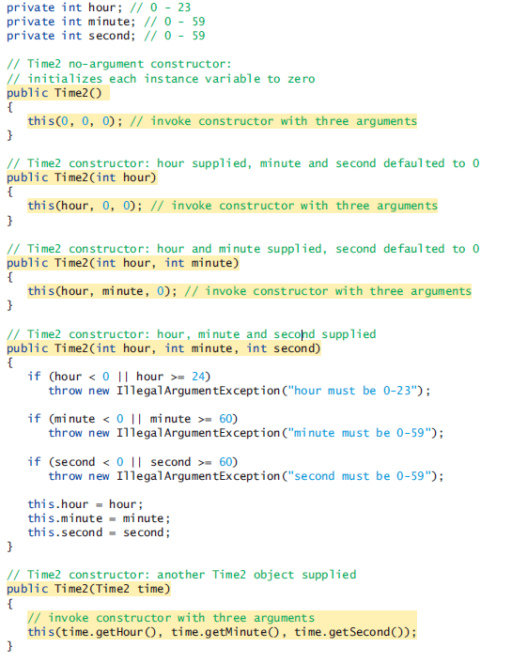

-We could have used time.hour, time.minute, time.second in the last constructor because objects of the same class can acces to each others private instance variables using objectName.variableName; We are in the same class. So those instance variables are in scope.

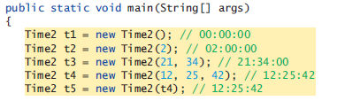

-When one object of a class has reference to another object of the same class, the first object can access all the second object’s data and methods (including those that are private). But this is not recommended. When use you use get and set methods you just need to maintain and change those. You dont have to maintain and change methods like toUniversalTime or toString when you use get methods in them.

**-Composition:** A class can have references to objects of other classes as members. This is called **composition** and is sometimes referred to as a *has-a* relationship. For example an employee object may need to know birth and hire dates. And they can be held as date objects.

public class Employee

{

private String firstName;

private String lastName;

private Date birthDate;

private Date hireDate;

**-enum Types**(import java.util.EnumSet):An enum type is declared with an enum declaration, which is a comma seperated list of enum constants. The declaration may optionally include other components of traditional classes, such as constructors, fields and methods.

-Each enum declaration declares an enum class with the following restrictions:

1. enum constants are implicitly final.

2. enum constants are implicitly static.

3. Any attempt to create an object of an enum type with operator new results in a

compilation error.

**-Declaring Instance Variables, a Constructor and Methods in an enum Type:** Constructors of enums are called enum constructors.

For every enum, the compiler generates the static method values that returns an array of the enum’s constants in the order they were declared.

One of the methods of EnumSet is range. Which returns an EnumSet that contains all the constants between these two constants.

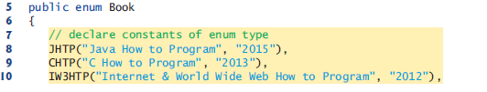

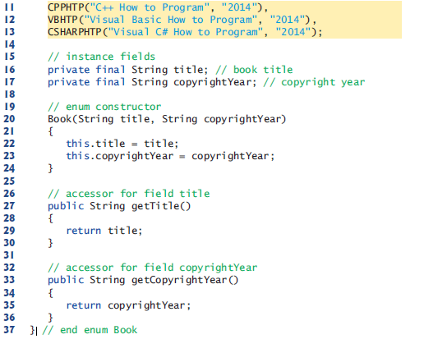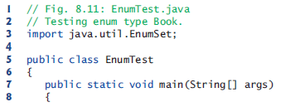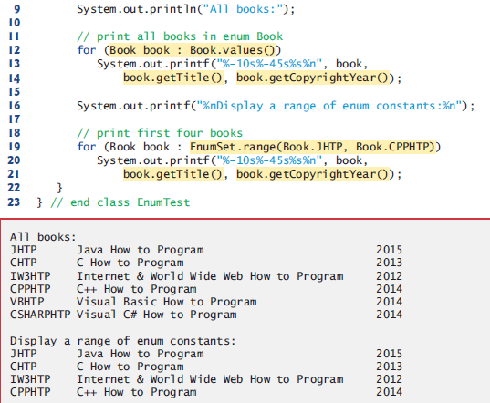

-The enhanced for statement can be used with the enumset we created too.

-In an enum declaration, it’s a syntax error to declare enum constants after the enum type’s constructors, fields and methods.

-We have a constructor but we dont create object of the enum. The defined constants gets set with the constructor. Thats why we need it. Constants have more to them just themselves unliek basic enums here. They have to be set to their constants. It is an array of constants(looks like objects with final fields) that are created from enum(looks like a class).

**-static import:** A static import declaration enables you to import the static members of a class

or interface so you can access them via their unqualified names(as opposed to fully qualified name—see package notes) in your class—that is, the class name and a dot (.) are not required when using an imported static member.

**-Static import forms:** A static import declaration has two forms—one that imports a particular static member(variable or method) (which is known as single static import) and one that imports all static members(variables and methods) of a class (known as static import on demand). The following syntax imports a particular static member:

import static java.lang.Math.sqrt; // import static *packageN*.*ClassN*.*staticMemberN*;

System.out.printf("sqrt(900.0) = %.1f%n", sqrt(900.0));

import static java.lang.Math.*; // import static *packageName.ClassName*.*;

System.out.printf("sqrt(900.0) = %.1f%n", sqrt(900.0));

System.out.printf("ceil(-9.8) = %.1f%n", ceil(-9.8));

System.out.printf("E = %f%n", E);

System.out.printf("PI = %f%n", PI);

* **Inheritance:** Inheritance is when a new class is created by acquiring an existing class’s members and possibly embellishing them with new or modified capabilities. The existing class is called the superclass, and the new class is the subclass. A subclass can become a superclass for future subclasses.

A subclass can add its own fields and methods. Therefore, a subclass is more specific than its superclass and represents a more specialized group of objects. The subclass exhibits the behaviors of its superclass and can modify those behaviors so that they operate appropriately for the subclass. This is why inheritance is sometimes referred to as specialization.

The direct superclass is the superclass from which the subclass explicitly inherits. An indirect superclass is any class above the direct superclass in the class hierarchy, which defines the inheritance relationships among classes. In Java, the class hierarchy begins with class Object (in package java.lang), which every class in Java directly or indirectly extends. Every object of a subclass is also an object of that class’s superclass. However, a superclass object is not an object of its class’s subclasses.

Java supports only single inheritance, in which each class is derived from exactly one direct superclass. But java uses polymorphism and interfaces to take advantage of multiple inheritance while avoiding the associated problems.

We distinguish between the is-a relationship and the has-a relationship. Is-a represents inheritance. In an is-a relationship, an object of a subclass can also be treated as an object of its superclass(direct and indirect)—e.g., a car is a vehicle. By contrast, has-a represents composition. In a has-a relationship, an object contains as members references to other objects— e.g., a car has a steering wheel (and a car object has a reference to a steering-wheel object).

**-Superclasses and Subclasses:** Often, an object of one class is an object of another class as well. For example, a CarLoan is a Loan.

-Inheritance relationships form treelike hierarchial structures. Class hierarchy is also called an inheritance hierarchy. Each arrow represents an is-a relationship. The top class is inherited from Object class. So we can say Employee is a CommunityMember and CommunityMember is an Object.

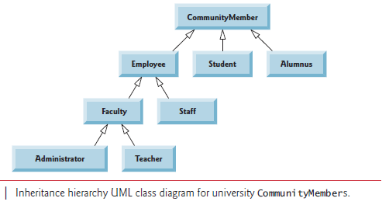

Objects of all classes that extend a common uperclass can be treated as object of that superclass.

**-members in inheritance:** public and protected superclass members retain their original access modifier when they become members of the subclass—public members of the superclass become

public members of the subclass, and protected members of the superclass become protected

members of the subclass. A superclass’s private members are not accessible outside the class itself. Rather, they’re hidden from its subclasses and can be accessed only through the public or protected methods inherited from the superclass. So we dont directly use private variables we inherit. We use them with public or protected methods. We cant directly use private members of superclass from subclass. We can only use them if we have access to them. We can call them using another member we have access to.

Constructors are not inherited. However, a subclass’s constructors are still avaiable to be called by subclass. In fact, Java requires that the first task of any subclass constructor is to call its direct superclass’s constructor, either explicitly or implicitly (if no constructor call is specified), to

ensure that the instance variables inherited from the superclass are initialized properly. Object’s default constructor does nothing. Even if a class does not have constructors, the default constructor that the compiler implicitly declares for the class will call the superclass’s default or no-argument constructor. If we are trying to call the constructor of this class we use this(). It can be used to overload constructor. (One constructor taking only one integer and calling another constructor with this(0, number);.

Subclass methods can refer to public and protected members inherited from the

superclass simply by using the member names. When a subclass method overrides an inherited

superclass method, the superclass version of the method can be accessed from the subclass by preceding the superclass method name with keyword super and a dot (.) separator.

-Bir subclass oluşturduğumuzda, o subclass’ta super gibi bir yol ile superclass’a gittiğimizde bir metod çalıştırılmak istenirse subclass’ın metodu varsa o kullanılır. Çünkü biz hala subclass’ın içindeyiz. Superclass’a geçici olarak geldik.

**-Relationship Between Superclasses ans Subclasses:** If you don’t explicitly specify which class a new class extends, the class extends Object implicitly.

-The book divides this section into 5 examples.

**Section 9.4.1:** class CommissionEmployee.

The only new thing about this example is the override.

**-Override:** A subclass can customize methods that it inherits from its superclass. To do this, the subclass overrides (redefines) the superclass method with an appropriate implementation, as we’ll see in the chapter’s code examples.

@Override // Overriding without reusing super’s method.

public String toString()

{

return String.format("%s: %s %s%n%s: %s%n%s: %.2f%n%s: %.2f",

"commission employee", firstName, lastName,

"social security number", socialSecurityNumber,

"gross sales", grossSales,

"commission rate", commissionRate);

}

F

@Override // Overriding with reusing super’s method.

public String toString()

{

return String.format("%s %s%n%s: %.2f", "base-salaried",

super.toString(), "base salary", getBaseSalary());

}

To override a superclass method, a subclass must declare a method with the same signature (method name, number of parameters, parameter types and order of parameter types) as the superclass method. Also the return type must be the same as, or a subtype of the return type in the original method.

Private, final and static methods cant be overridden but can be redefined. These methods cant be inherited from superclass. So you have to define these methods from scratch.You cant call super.method like inherited methods sometimes do inside them.

Optional @Override annotation to indicate that the following method declaration (i.e., toString) should override an existing superclass method. This annotation helps the compiler catch a few common errors. For example signature not matching errors.

It’s a compilation error to override a method with a more restricted access modifier. Doing so would break the is-a relationship, which requires that all subclass objects be able to respond to method calls made to public methods declared in the superclass.

**Section 9.4.2:** classBaseCommissionEmployee.

**-Why we need inheritance:** We literally copied code from class CommissionEmployee and pasted it into class Base- PlusCommissionEmployee, then modified class BasePlusCommissionEmployee to include a base salary and methods that manipulate the base salary. This “copy-and-paste” approach is often error prone and time consuming. Worse yet, it spreads copies of the same code throughout a system, creating code-maintenance problems—changes to the code would need to be made in multiple classes. Is there a way to “acquire” the instance variables and methods of one class in a way that makes them part of other classes without duplicating code? Next we answer this question, using a more elegant approach to building classes that emphasizes the benefits of inheritance.

**Section 9.4.3:** classBaseCommissionEmployee extends CommissionEmployee.

Our program doesnt work because subclass methods cant access to private instance variables of superclass.

At the design stage in an object-oriented system, you’ll often find that certain classes are closely related. You should “factor out” common instance variables and methods and place them in a superclass. Then use inheritance to develop subclasses, specializing them with capabilities beyond those inherited from the superclass.

**-Explicit call to superclass constructors and accessing super members:** We set the values of the variables of superclass to superclass. Subclass doesn’t have direct access to private members of superclass.

As we said before we have to call one of the constructors of super class first thing in subclass constructor. We do this by using the superclass constructor call syntax, super(argument list)—keyword super, followed by a set of parentheses containing the superclass constructor arguments, which are used to initialize the superclass instance variables.

We have direct access to non private variables and methods. From subclass itself you can directly use them(use super. For shadowing local variables). From outside subclass lets say a test class that creates a subclass. You first need to create a subclass and then use subclassName.variableName; or subclassName.methodName();

BasePlusCommissionEmployee employee = new BasePlusCommissionEmployee(

"Bob", "Lewis", "333-33-3333", 5000, .04, 300);

System.out.printf("%n%s %s%n", "First name is",

employee.getFirstName());

Calling constructor of super from subclass constructor:

public BasePlusCommissionEmployee(String firstName, String lastName, String socialSecurityNumber, double grossSales, double commissionRate, double baseSalary)

{

super(firstName, lastName, socialSecurityNumber, grossSales, commissionRate);

**Section 9.4.4:** classBaseCommissionEmployee extends CommissionEmployee.

To reach instance methods of superclass we need to either make them protected or use public get methods. In this example we use protected.

**-Subclass containts instance variables of all of its superclasses:** When you create a BasePlusCommissionEmployee object, it contains all instance variables declared in the class hierarchy to that point—that is, those from classes Object (which does not have instance variables), CommissionEmployee and BasePlusCommissionEmployee. Class BasePlusCommissionEmployee does not inherit CommissionEmployee’s five-argument constructor, but explicitly invokes it (lines 14–15) to initialize the instance variables that BasePlusCommissionEmployee inherited from CommissionEmployee. Similarly, CommissionEmployee’s constructor implicitly calls class Object’s constructor. BasePlusCommissionEmployee’s constructor must explicitly call CommissionEmployee’s constructor

because CommissionEmployee does not have a no-argument constructor that could be invoked

implicitly.

**-Problems with using protected variables instead of methods:**

Using protected instance variables creates several potential problems. First, the subclass

object can set an inherited variable’s value directly without using a set method.

Another problem with using protected instance variables is that subclass methods are more likely to be written so that they depend on the superclass’s data implementation. In practice, subclasses should depend only on the superclass services (i.e., non-private methods) and not on the superclass data implementation. Such a class is said to be fragile or brittle, because a small change in the superclass can “break” subclass implementation. You should be able to change the superclass implementation while still providing the same services to the subclasses. Of course, if the superclass services change, we must reimplement our subclasses.

A third problem is that a class’s protected members are visible to all classes in the same package as the class containing the protected members— this is not always desirable.

**Section 9.4.5:** class BaseCommissionEmployee extends CommissionEmployee.

Even when we have access to a variable its good practice to access it with methods. This way if its name changes the program wont crash.

**-Calling methods from constructors:** When you create a subclass its constructor is automatically called. Before the constructor if subclass executes, the constructor of superclass executes. And if there is a method call in superclass constructor methods in subclass shadow methods in superclass. (If subclass has overriden methods) But when fields are used in these methods, fields of the current class is used, not the class we came from. So if method of class B is executing, field of B will be used no matter if method was called from B or subclass C.

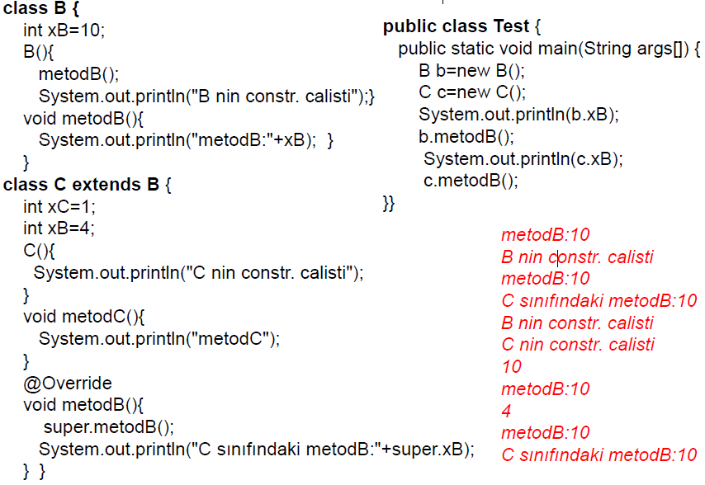

**-Calling constructors of super from subclass constructors:** Explicitly specify which constructor of super to execute at the beginning of subclass constructors. What happens if you dont specify?

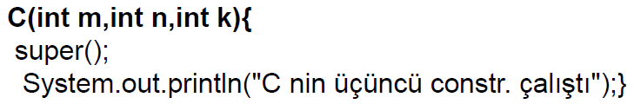

**-Overriding fields and methods:** Override is used if we want the subclass to not use the member of superclass. If we dont want subclass to inherit a field from superclass we just declare a field with the same name in subclass.

**-Class Object:** As we discussed earlier, all classes in Java inherit directly or indirectly from class Object (package java.lang), so its 11 methods (some are overloaded) are inherited by all other classes.

Class Object’s toString method returns a String that includes the name of the object’s class. It’s primarily a placeholder that can be overridden by a subclass to specify an appropriate String representation of the data in a subclass object.

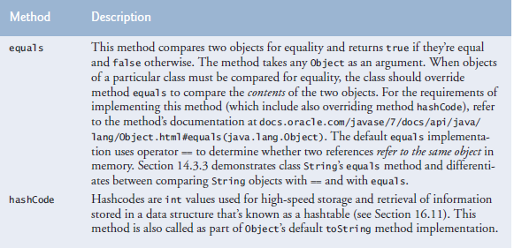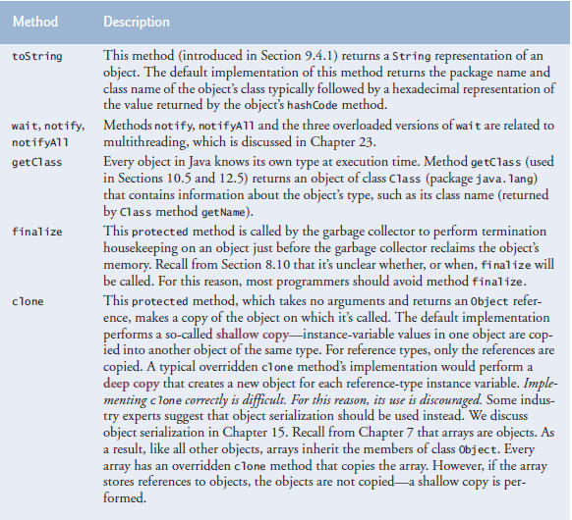

(tag: equals, hashCode, toString, wait, notify, notifyAll, getClass, finalize, clone)

* **Polymorphism and Interfaces:**

-When a superclass variable contains a reference to a subclass object, and that reference is used to call a method, the subclass version of the method is called. Why don’t we just use reference variable for subclass then?

CommissionEmployee commissionEmployee2 = BasePlusCommissionEmployee;

System.out.printf("%s %s:%n%n%s%n", "Call BasePlusCommissionEmployee's toString

with superclass", "reference to subclass object", commissionEmployee2.toString());

Call BasePlusCommissionEmployee's toString with subclass reference to

subclass object:

base-salaried commission employee: Bob Lewis

social security number: 333-33-3333

gross sales: 5000.00

commission rate: 0.04

base salary: 300.00

* **Polymorphism and Interfaces:** Is the ability of an object to take on many forms. The most common use of polymorphism in OOP occurs when a parent class reference is used to refer to a child class object. Any Java object that can pass more than one IS-A test is considered to be polymorphic.

**-**Java doesnt support multiple inheritance(direct inheritence from multiple classes) but it uses polymorphism and interfaces to realize many of the benefits of multiple inheritance while avoiding the associated problems.

-A reference variable can refer to any object of the same type or any subtype of the declared type. A reference variable’s type determines the methods that can be invoked on the object the variable is referencing. A reference variable can be declared as a class type or an interface type.

When we declare “Animal myDog = new Dog();” and call the method makeNoise the method of dog executes not animals. So why do we do it? Because we can assign other objects to it. (Casting)

**-Casting:**

**-Upcasting:** Casting an object to a more generalized type.

**-Downcasting:** Casting an object to a more specialized type. (Allowed but not recommended)

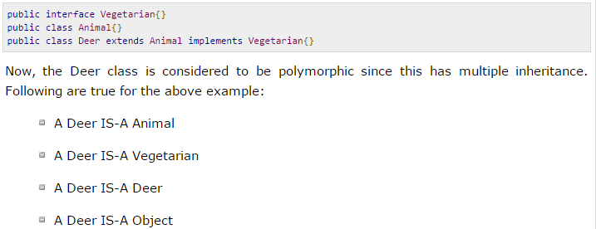

**-Abstraction:** Abstraction is a process process of hiding the implementation details from the user, only the functionality will be provided to the user. In other words user will have the information on what the object does instead of how it does it.

-Abstract classes may or may not include abstract methods.

-Abstract classes cannot be instantiated, but they can be subclassed.

-An *abstract method*is a method that is declared without an implementation

-An abstract class is a class with one or more abstract methods. An abstract methods is a method with no body. Abstract methods should be implemented in the first concrete class. An abstract method cant be instantiated.

abstract void moveTo(double deltaY);

-If a class includes abstract methods, then the class itself *must*be declared abstract, as in:

public abstract class GraphicObject {

abstractvoid draw(); }

-When an abstract class is subclassed, the subclass usually provides implementations for all of the abstract methods in its parent class. However, if it does not, then the subclass must also be declared abstract.

Örnek:

abstract class GraphicObject {

int x, y; ...

void moveTo(int newX, int newY) { ... }

abstract void draw();

abstract void resize(); }

class Circle extends GraphicObject {

void draw() { ... }

void resize() {... } }

class Rectangle extends GraphicObject {

void draw() { ... }

void resize() {... } }

**-Abstract implementing:** Implement some of the methods of interface at class and rest at object.

abstract class X implements Y {

// implements all but one method of Y }

class XX extends X {

// implements the remaining method in Y }

**-Interface:** Metod ve field içerebilirler. .java dosyasının ismini alırlar public class gibi. Class’ların .class dosyasına dönüşmesi gibi interface’lerde .class dosyasına dönüşür. Tüm metodları soyut be publictir. Interface’ler private veya protected olamazlar. Nesneleri üretilemez. İnterface instance variable’lar are implicitly public, static, final. Constructor içermezler. Bir arayüz başka arayüzlerden miras alabilir. Sınıflar sadece başka bir sınıfın kalıtımı olabilirken arayüzler birden çok arayüzden kalıtım alabilirler. Interfaces are implicitly public and abstract.

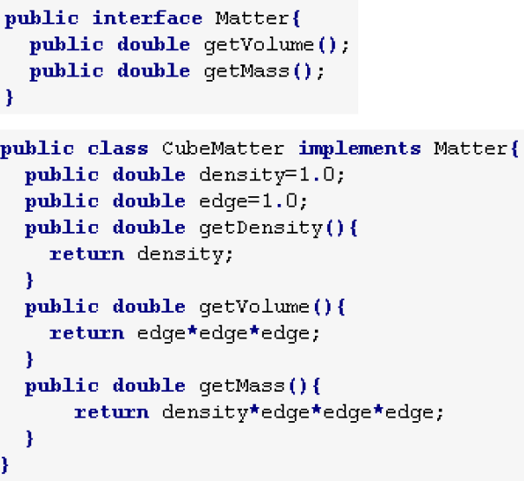

-We have to implement all methods of the interface. A class can implement as many interfaces as as it wants but it can extend only one class. Interfaces can implement as many interfaces as they want too.

* Object Oriented Programming part2(bundan onceki part ile birlestirilecek)

**- Encapsulation and information hiding:** Bilgiyi paketleme ve gizli olanları dışarıyla direk paylaşmamadır. Gizli verilere metodlarla erisilir.

**- Inheritance** Bilgiyi üst sınıflardan miras almaktır.

**- Abstraction** Abstraction is mechanism to show only relevant data to the user.

**- Polymorphism:** Bir class’tan çeşitli object’ler elde edebilmemiz.

**-Encapsulation**: Encapsulation in Java is a mechanism of wrapping the variables and methods together as a single unit. In encapsulation the variables of a class will be hidden from other classes, and can be accessed only through the methods of their current class, therefore it is also known as data hiding(information hiding).

To achieve encapsulation in Java

-Declare the variables of a class as private.

-Provide public setter and getter methods to modify and view the variables values.

* **Exception Handling:** An exception indicates a problem that occurs while a program executes. The name “exception” suggests that the problem occurs infrequently—if the “rule” is that a statement normally executes correctly, then the problem represents the “exception to the rule.”

Exception handling enables you to create fault-tolerant programs.

An exception object’s toString method returns the exception’s error message.

-All errors and exceptions inherit from the Throwable class.

-When we specify that the method throws certain exceptions we dont have to handle it.

-You can explicitly throw an exception after catching it to send it to upper scope to be handled.

catch(SomeException ex) {

System.err.println(Some exception occured);

Throw ex;

}

A catch block declares a type and an exception parameter. Inside the catch block, you can use the parameter’s identifier to interact with a caught exception object.

**try, catch, throw, throws and error types:** error = exception. E birçok hatayı içeren genel bir hata yakalama parametresi.

<https://www.tutorialspoint.com/java/java_builtin_exceptions.htm>

**-Error, Exception**

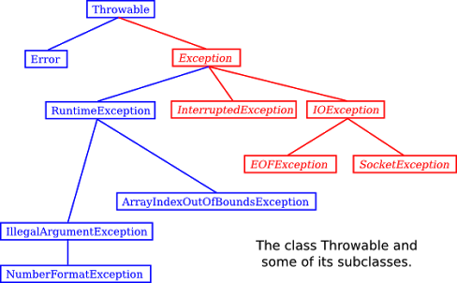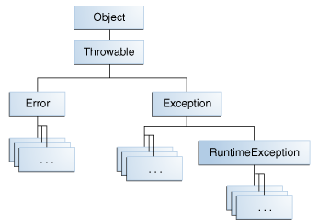

-Runtime exception and all of its subclasses are called unchecked exceptions.

-**syntax error(**compiler error, compile time error, compliation error):

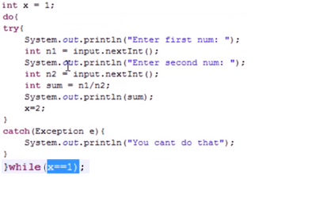

Normalde throw kullanmaya gerek yoktur. Çünkü bir hata olursa otomatik olarak hata atılır. Ama biz bilgisayarın hata olarak görmediği ama bizim hata olmasını istediğimiz birşey olduğunda kendimiz throw ekliyoruz. Alttaki örnekte bunu yapıyoruz. Eğer sayı eksi ise hata ver diyoruz.

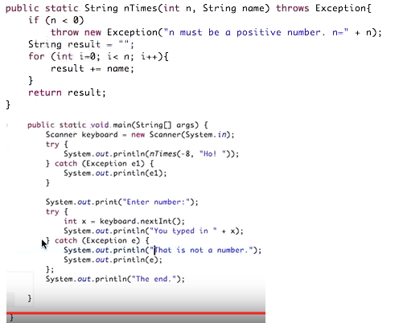

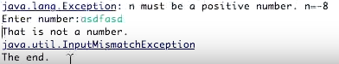

When you have a throw in a method, you have to put “throws Exception” to method signature. If you use this method in your program, you have to surround it with a try catch block. Because it might return an exception.

Exception’lar sınıftır. Throw new dediğimizde bir exception sınıfına ait bir nesne yaratırız. Exception gibi genel bir hata ifadeside kullanabiliriz, tam hata sınıfınıda kullanabiliriz. Bu yarattığımız sınıfa parametre(not) da veriririz. Catch’te ise sınıfımıza isim veririz. Mesela e1.

Altta ise throw yok. Yani biz bilgisayarın görmediği bir hata tanımlamıyoruz. Bilgisayar integer girilmediğini anlarsa genel olmayan, kesin olan bir hata gönderiyor. Catch’ te exception da diyebiliriz, kesin hata nesnesinide kullanabiliriz. Bu sefer e ismini veriyoruz.

Catch hiçbirşey yapmaz. Catch’in altındaki satırlar iş yapar. Print e1 demek yukarda throw e1 daki hata adı ve yanındaki notu yaz demektir. Bu yüzden üstteki catch’den sonra bir satır vardır. Alttaki catch’in altında önce bir satır not yazdırılır sonra hatanın adı ve not yazdırılır(bu sefer not yok).

Print(e1) demek yerine printing içinde getMessage kullanabiliriz. System.out.print(" Hata oluştu :" + Hata.getMessage());

1- Bir hata yakaladığında hatayı yazdırabilirsin(print e1) bu sana hatanın tam adını verir. Eğer bunu yaparsan sadece hatanın adını yazmakla kalmaz, üstte throw’un yanında yazdığın notuda ekler.

2- Sadece kendi istediğin bir yazıyı yazdırabilirsin catch’in altındaki print’te. Böylelikle hatanın adı gelmez ve yukardaki throw’un yanındaki yazı gelmez.

3- Başka eylemler yaptırabilirsin.

Add this to notes <https://dzone.com/articles/java-7-new-try-resources>

* **GUI (Graphical User Interface) Components**

**-Using Dialog Boxes:**

import javax.swing.JoptionPane;

JoptionPane.showMessageDialog(null, “Hello World”);

-showMessageDialog method is static. It displays a dialog box(also called dialog). There are different types of dialog boxes. Message dialog will show a message to you. Input dialog will ask for an input from you. Message method requires two arguments. First argument determines where will display box be displayed. These boxes normally pop up from the main gui application. And they stay in their application’s borders. So if we had a window reference we would use it here as first argument to display our box in the middle of that box. Entering null means display the box in the middle of the screen. Second argument is the string to display in the dialog box.

import javax.swing.JoptionPane;

String name = JoptionPane.showInputDialog(“What is your name”);

String message = String.format(“Welcome, %s, to Java Proramming!”, name);

JoptionPane.showMessageDialog(null, message);

-Input dialog both has a prompt and a field (known as text field)where user can enter text. Pressing ok button or pressing enter returns the string containing characters to program and saved in the string “name”. If you press the cancel button or esc key the method returns null and the program displays the word “null” as the name.

import javax.swing.JoptionPane;

String firstnumber = JoptionPane.showInputDilog( “Enter integer” );

int number1 = Integer.parseInt( firstNumber );

JoptionPane.showMessageDialog ( null, “Number is “ + number1 );

**-Displaying Text and Images Using Labels:**

In java, a label can display text, an image or both at the same time. Since we specify only a filename, java assumes that image is in the same directory as class LabelDemo. (Dont use default package.) ImageIcon can load images in GIF, JPEG and PNG formats.

**-Determining which button is activated when you press enter after typing:** Every TextField, TextArea, etc. can execute statements just like buttons do when they are activated. Activating a button is generally done from text fields/areas and you assign which button is pressed from which text field/area.

private void txtMessageActionPerformed(java.awt.event.ActionEvent evt) {

btnSendActionPerformed(evt); // ..ActionPerformed method of btnSend button.

}

* **Strings, Characters and Regular Expressions**

**String(character string, string literal):** String is an object. String objects in java are immutable—they cannot be modified after that are created.

squareCharacter = input.next().charAt(0);

-You cant use concat by itself. You have to assign the return value(address of the new string) to a string reference.

-Field strings have default values initialized but not local strings.

-Strings cant be edited. They can be destroyed and created.

-Strings are reference types but act like primitive types in that they can be initialized like primitive type variables.

**-Stack and heap of Strings:** If we initialize strings without using new, string is kept in. In string pool you can have only one copy of one string such as “test1”. So you dont waste memory. All strings that are equal to this point to it. If we use new to create strings, a string is created in heap. Every new string created with new has its own memory even if they are the same string. String pool is in heap in its own memory.

[https://docs.oracle.com/javase/7/docs/api/java/lang/String.html#intern()](https://docs.oracle.com/javase/7/docs/api/java/lang/String.html%23intern())

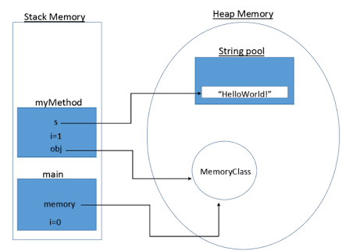

-String atama yolları:

1) String a = "Hello World!";

2) String a = new String( “java” );

3) String a = new String( array ); // Assigning an array to a string.

String s4=new String(dizi,6,3); // 6.indisten itibaren 3 karakter

-Char dizisi atama yolları

1) char[] array={'b','i','r','t','h',' ','d','a','y'};

2) char array[] = new char[10];

**-string1.format():** printf displays formatted string, String.format returns it to save in a string.

String a = String.format( "This is a number: %s and this is a string: \"%s\"", 3 * x, string2);

-String.format olmadanda ayni isi yapabiliriz string concatenation ozelligini print fonksiyonu disinda kullanarak. i

String a = "This is a number: " + 3 * x + " and this is a string: \"" + string2 + "\"";

**-string1.length:** String’in değil karakter sayısının( string-1 ) uzunluğunu verir.

println( "Uzunluk " + FirstString.length() );

**-string1.charAt(n):** 2. Karakteri verir(2. İndisteki değil).

"\n s2 2. karakter:"+s2.charAt(1)

**-string1.getChars(1, 8, dizi1, n):** 1.indisten 8.indis e kadar dizi1 e 0. indisinden itibaren kopyala

s3.getChars(1,8,dizi1,0);

-**string1.equals("merhaba dünya"):** Karşılaştırma operatörü olarak kullanılılır, harflere büyük küçük harf duyarlılığı ile bakar. Always put the value/variable you know for sure is a string to the left so the program doesnt break when it uses a non String. Dont use “==” operator to compare values of objects because it compares the references not the objects.

if ("hello".equals(a1))

System.out.println("a1 equals \"hello\"");

if ("Happy Birthday" == a3)

System.out.println("a3 = Happy Birthday");

**-string1.isEmpty():**

if(str != null && str.isEmpty()) // If our string is empty

if(str != null && !str.isEmpty()) // If our string is not empty

-**string1.equalsIgnoreCase("merhaba dünya"):** Karşılaştırma oparatörü olarak kullanılır, büyük küçük harfe bakmaz sadece aynı harflermi değilmi ona bakar.

if (a3.equalsIgnoreCase(a4))

System.out.printf("%s equals %s with case ignored\n",a3,a4);

- i=**string1.compareTo("zehra")**; st1 büyükse pozitif küçükse negatif eşitse i 0 olur .

-print(**string1.indexOf("dunya")**): d’nin indisini verir, Aranan metin bulunamazsa -1 döndürür.

-println(**myString.indexOf("dunya", n)**): n. indisten başlayarak d karakterine bak.

-println(**myString.indexOf( ‘d’, n ):** d karakterine n. indisten başlayarak bak.

-**string1.lastIndexOf():** Karakterin son kullanıldığı indexi gösterir. Karakter yoksa -1 döndürür.

System.out.printf(" son'c' karakterinin indisi:%d\n",harfler.lastIndexOf('c'));

-**string1.lastIndexOf(‘c’, n):** soldan 14. İndexten başlayarak a karakterinin son kullanıldığı indexi döndürür.

harfler.lastIndexOf('a',14)):,

-**string1.toCharArray():** s array’ini dizihali string’ine atar.

char[] dizihali=s.toCharArray();

- **myString.toLowerCase():** String’i küçük harf yapar.

- **myString.toUpperCase():** String’i büyük harf yapar.

- System.out.println(**myString.trim()**): Baş ve sondaki boşlukları yok eder.

- String[] words = **myString.split(" ")**: Bu örnekte boşluk görünce parçaya ayırıyor string’i. Split kullanmadan şu şekilde yapılabilir.

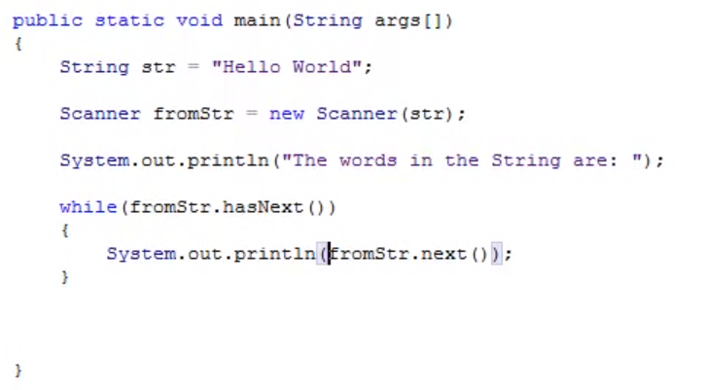

-**string1.startsWith(“c”):** string1’in c karakteriyle(yada string aramasıda yapılabilir) başlayıp başlamadığına bakar. Ayrıca (“c”, 2) diyerek 2. İndisten itibaren c karakteri ile başlayıp başlamadığınada bakabiliriz.

-**string1.endsWith(“c”):** string1’in c karakteriyle bitip bitmediğine bakılır. Karakter yerine string aramasıda yapılabilir.

- String string2 = **string1.substring(0, 4)**; string1’in 0. İndexinden 4. İndexine kadar olan kısmını aldık.

-**String replace(oldchar, newChar)**: Changes all the old char with new char.

http://docs.oracle.com/javase/7/docs/api/java/lang/String.html

-You can also use String.format.

String a = String.format( "This is a number: %s and this is a string: \"%s\"", 3 * x, string2);

String a = "This is a number: " + 3 * x + " and this is a string: \"" + string2 + "\"";

-string bigger and string builder uses just one string when you concat unlike using String class.

* **Advanced I/O and Serialization** (import java.io.*)

-EOF(End Of File): “See C Notes”

**-Text dosyası yaratma ve yazı yazma:**

**FileOutputStream** f = new FileOutputStream("C/proje/src/yaz1.txt");

**PrintStream** yaz = new PrintStream(f);

yaz.println(string1);

yaz.print(4);

yaz.print('%');

**-Satır girişi:** İlk satır neyin okunacağını belirtir. İkinci satır okunan satırın nerede depolanacağını belirtir. Üçüncü satırda b’nin ilk \n’sına kadarının s’ ye ataması yapılır.

**InputStreamReader** a = new InputStreamReader(System.in);

**BufferedReader** b = new BufferedReader(a);

s = **b.readLine()**;

**-Dosyadan satır satır okuma:** buf.readLine() text dosyasındaki ilk satırı alır ve sonrakine geçer.

**FileInputStream** fi=new FileInputStream("D:\proje \src\yaz1.txt");

**BufferedReader** b=new BufferedReader(new InputStreamReader(fi));

while ((satır1=**b.readLine()**)!=null)

System.out.println(satir1);

**-Dosyadan kelime kelime okuma:** object class’ındaki **nextElement** metodunu bu sefer iki kere kullandık. Çünkü sadece satırları değil satırlar içindeki kelimeleride böldük.

**FileInputStream** fi=new FileInputStream("C/proje/src/newfile.txt");

**BufferedReader** b=new BufferedReader(new InputStreamReader(fi));

**StringTokenizer** st;

while ((satir1=b.readLine())!=null)

st=new StringTokenizer(satir1);

while (st.hasMoreTokens())

System.out.println(st.nextToken());

**-Dosyadan karakter karakter okuma:** -1 e kadar oku dersen null yan son karaktere kadar tüm karakterleri tek tek yazdırır.Herhangi başka bir karakteri -1 yerine yazabilirsin. Ama sayı formunda olması için ‘u’, ‘\n’ şeklinde yazman gerekiyor.

**StringBuffer** icerik = new StringBuffer("");

**File** f=new File("C:/ proje/src/newfile.txt");

**FileInputStream** fi=new FileInputStream(f);

int k;

while ((k=fi.read())!=-1)

icerik.append((char)k);

* **Accessing Databases With JDBC(Java Database Connectivity):**

**-Conventions:**

**-**All table names should be all uppercase with words seperated by underscores.

-All column names should start with table name or its initials. (e.g., contacts_name).

* **JPA(Java Persistance Api)** (javax.persistance.*)

-Supported types of entity classes primitive types, String, other serializable objects.

-one to one, one to many, many to one, man to many etc.

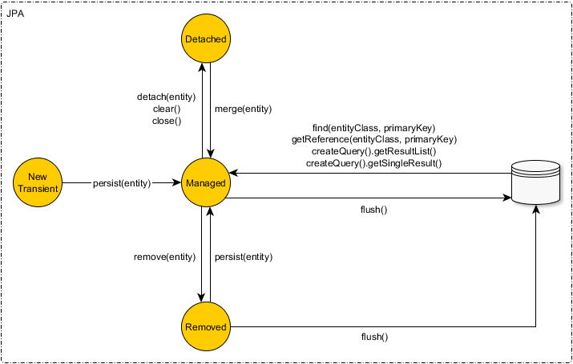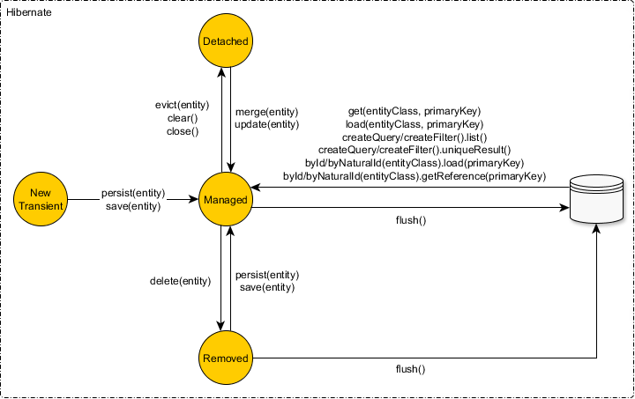

<https://vladmihalcea.com/2014/07/30/a-beginners-guide-to-jpa-hibernate-entity-state-transitions/>

* **Server-side programming / Dynamic Pages:**

Servlet is server side programming API of java. Its difference from JSP, ASP and PHP is, it handles http requests and responses manually.

JSP is a server side Java view technology. JSPs are compiled into Java code and run as Java Servlet.  allows you to write template text in client side languages (like HTML, CSS, JavaScript, ect.). JSP supports [taglibs](http://docs.oracle.com/javaee/5/tutorial/doc/bnann.html), which are backed by pieces of Java code that let you control the page flow or output dynamically, JSP also supports [Expression Language](https://stackoverflow.com/tags/el/info), which can be used to access backend data,

JSF is a server side programming framework for Java. JSFs are built on top of Servlet API. Web pages and back end code is seperated like ASP.

As being a MVC ([Model-View-Controller](http://en.wikipedia.org/wiki/Model%E2%80%93view%E2%80%93controller)) framework, JSF provides the [FacesServlet](http://docs.oracle.com/javaee/6/api/javax/faces/webapp/FacesServlet.html) as the sole request-response Controller. It takes all the standard and tedious HTTP request/response work from your hands, such as gathering user input, validating/converting them, putting them in model objects, invoking actions and rendering the response. This way you end up with basically a JSP or Facelets (XHTML) page for View and a JavaBean class as Model. The JSF components are used to bind the view with the model (such as your ASP.NET web control does) and the FacesServletuses the JSF component tree to do all the work.

ASP is server side programming framework of C#.

PHP is a open source server side programming language(Not framework. Servlet, JSP and ASP uses Java and C# programming languages.)

**-Web Notes**

-WEB-INF is private. So put your web pages(html, JSP, etc.) in root of file Web Pages.

-F12 to open developer tools.

-Use xml for selecting which file will be shown as main page

<welcome-file-list>

<welcome-file>faces/index.xhtml</welcome-file>

</welcome-file-list>

Extensible Markup Language (XML) is a [markup language](http://pl.4everproxy.com/secure/rKXZPdgK5CaJALtgCWEexIU6QjAM22VYE3~Jgbkmfb8IGqIzWXB3Cq7FUSxSuZxY) that defines a set of rules for encoding [documents](http://pl.4everproxy.com/secure/rKXZPdgK5CaJALtgCWEexFTxU9ck9u7pgsPrqU7uU1LH_DCH~EWHz8sBbiDLsPpcAT0xqMzLbA_gV~Dwrjcq7A--) in a [format](http://pl.4everproxy.com/secure/rKXZPdgK5CaJALtgCWEexPB4LKJHzXYtkVMQFAaW9Ogr01w9ZeCLRoiCAXp2SErw) that is both [human-readable](http://pl.4everproxy.com/secure/rKXZPdgK5CaJALtgCWEexDCvcA_e1tVSQg_6xjnZXulaGiu6Hm_U88A4I6Vf4bUo3hIXRilpVLh3BFGnql6Cxg--)and [machine-readable](http://pl.4everproxy.com/secure/rKXZPdgK5CaJALtgCWEexIU6QjAM22VYE3~Jgbkmfb8i1Vr6MLPldiXtrdcsdv5C04jkkr8QDmsUikriq1wUig--).

The framework handles the details of receiving client requests and returning responses for you so that you can focus on your application’s functonality.

**-HyperText Transfer Protocol (HTTP) Transactions:** Section 30.2 explains XHTML, URL and hyperlinks, hosts, IP, DNS,

-For a computer to be a web-server, it needs to run web-server software which make resources avaiable.

-Parts of url: Url contains the protocol to obtain resources with. Could be http, ftp etc. www.deitel.com is the fully qualified hostname aka name of the server/host. Rest of the URL specifies both the name of the requested source “downloads.html” and its path/location on the server.

http://www.deitel.com/books/downloads.html

-“localhost” is the reserved domain name which translates to 127.0.0.1.

-Fully qualified name can be followed by a colon (:) and a port number. Web servers typically await requests on port 80 by default: however, many development web servers use a different port number such as 8080.

-Some servers might use virtual directory. The virtual directory is translated into a real location on the server(or on another computer on the server’s netwokr), thus hiding the resource’s true location for security reasons.

-HTTP is used by web browsers to communicate with web browsers. We send HTTP requests to the server to get resources.

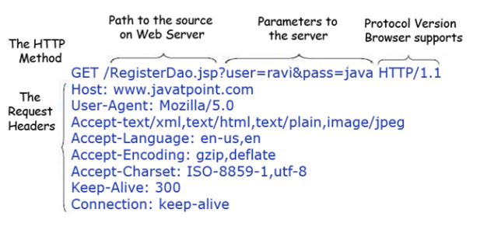

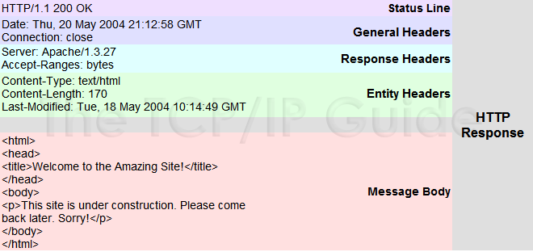

-If an HTTP request is unsuccessful the server responds by sending a line of text that indicated the HTTP version, followed by a numeric code and a phrase describing the status of the transaction.

HTTP/1.1 200 OK

Indicates success, whereas

HTTP/1.1 404 Not found

Informs the client that the web server could not locate the requested resource.

On a successful request, the server appends the requested resource to the HTTP response.

<https://www.w3.org/Protocols/rfc2616/rfc2616-sec10.html>

-The Content-Type header specifies the MultiPurpose Internet Mail Extension(MIME) type of the content that the server is transmitting to the browser.

-Header lines are followed by a blank line.

-Get and post methods are known as request methods. Get request typically asks for a resource on a server like html documents, images, search engine results. They can also be used to carry data over headers(URL). When you are using get to get a document with parameters you put a “?” at the end of the game and enter the parameter names and their values as

…?name=anil&age=21

Example above sends data to server using gget method. Uses URL. Not safe. Post uses http body and safer than get when sending data.

Right side of ? is called query string. The server uses data passed in a query string to retrieve an appropriate resource. The server then sends a response to the client. http doesnt limit character number of query string but some browsers do.

Post request typically sends data to a server such as sending form data or documents. Get method can carry form data too but not secure. The code that take cares of the form data in server is called server-side form handler. The data is not in header part of http(URL). It is in the HTTP body. Get method does not limit the query string’s number of characters, but some web browsers do. So it’s often necessary to send large pieces of information using POST. Sometime POST is preferred because it hides the submitted data from the user by embedding it in an HTTP message. GET methods are not secure but tools to expose POST method’s data exist too.

**-Client side caching:** Caching is used when internet speed is not high enough. To get around this problem you save frequently requested documents on client side. When a client asks for that document you dont try to get the whole document, you first ask to server if the document has changed since you last cached it. If not the cache file is used. If it changed then it is requested from the server.

**-Multitier Application Architecture:** Web apps are multitier applications (sometimes referred to as n-tier aplications). Multitier applications divide functionality into seperate tiers a (i.e., logical grouping of functionality). Although tiers can be located on the same computer, the tiersof web apps often reside on seperate computers.

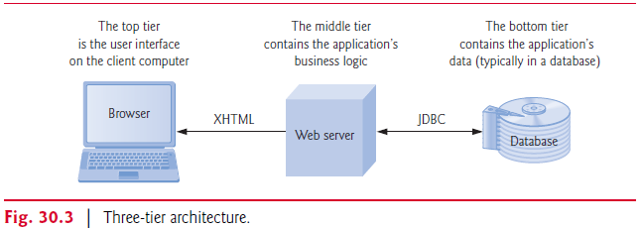

-The information tier (also called the data tier or the bottom tier) maintains data pertaining to the application. This tier typically stores data in a relational database management system (DRBMS). This tier can contain multiple databases, which together comprise the data needed for our application.

The middle tier implements business logic, controller logic and presentation logic to control interactions between the application’s clients and the application’s data to users. The middle tier acts as an intermediary between data in the information tier and the application’s clients. The middle-tier controller logic processes client requests and retrieves data from the database. The middle-tier presentation logic then processes data from the information tier and presents the content to the client. Web apps typically present data to client as HTML documents.

Business logic in the middle tier enforces business rules and ensures that data is reliable before the server application updates the database or presents data to users. Business rules dictate how clients can and cannot access application data, and how applications process data.

The client tier, or top tier, is the application’s user interface, which gathers input and displays output. User interact directly with the application through the user interface (typically viewed in a web browser), keyboard and mouse. In response to user actions (e.g., clicking a hyperlink), the client tier interacts with the middle tier to make requests and to retrieve data from the information tier. The client tier then displays the data retrieved from the middle tier to the user. The client tier never directly interacts with the information tier.